Table of Contents

Summary 2

Zero HVDC power: Illustration 3

Zero HVDC power: UDC step down 4

Zero HVDC power: UDC step down 5

Zero HVDC power: UDC step up 6

Zero HVDC power: UDC step up 7

Zero HVDC power: P step down 8

Zero HVDC power: P step down 9

Zero HVDC power: P step up 10

Zero HVDC power: P step up 11

Zero HVDC power: VAC step up 12

Zero HVDC power: VAC step up 13

Zero HVDC power: VAC step down 14

Zero HVDC power: VAC step down 15

Zero HVDC power: 3pSC fault at the grid's PCC 16

Zero HVDC power: 3pSC fault at the grid's PCC 17

1GW HVDC power: Illustration 18

1GW HVDC power: UDC step down 19

1GW HVDC power: UDC step down 20

1GW HVDC power: UDC step up 21

1GW HVDC power: UDC step up 22

1GW HVDC power: P step down 23

1GW HVDC power: P step down 24

1GW HVDC power: P step up 25

1GW HVDC power: P step up 26

1GW HVDC power: VAC step up 27

1GW HVDC power: VAC step up 28

1GW HVDC power: VAC step down 29

1GW HVDC power: VAC step down 30

1GW HVDC power: 3pSC fault at the grid's PCC 31

1GW HVDC power: 3pSC fault at the grid's PCC 32

# Summary

* HVDC model is included in the base scenario for the SMIB model: SCR=5, generator active power is 1170 MW, and PSS is active.
* **HVDC active power is either zero or 1 GW.**
* **HVDC Slave converter is in Vac control.**

The HVDC tuning is done for the following tests:

* UDC steps of +/- 3% (on Master converter)
* Active power steps for +/- 1 pu (Slave converter, 1400 MW unless limited)
* Reactive power steps of +/- 0.3 pu (Slave converter when in Q ctrl)
* Uac steps of 0.03 pu (Slave converter when in Uac ctrl)
* Three-phase short-circuit fault at the HVDC bus for 100 ms

The simulations last for 10 seconds, and the event start at 2 seconds.

All the results are provided between 1.99 to 4 seconds for convenience.

The plotted variables are the following:

HVDC (both Slave and Master):

* Active power
* Reactive power
* AC voltage
* AC current
* DC voltage
* DC current

NPP:

* Generator bus voltage
* Active power
* Reactive power
* Excitation voltage
* Frequency deviation
* Internal Rotor angle

# Zero HVDC power: Illustration

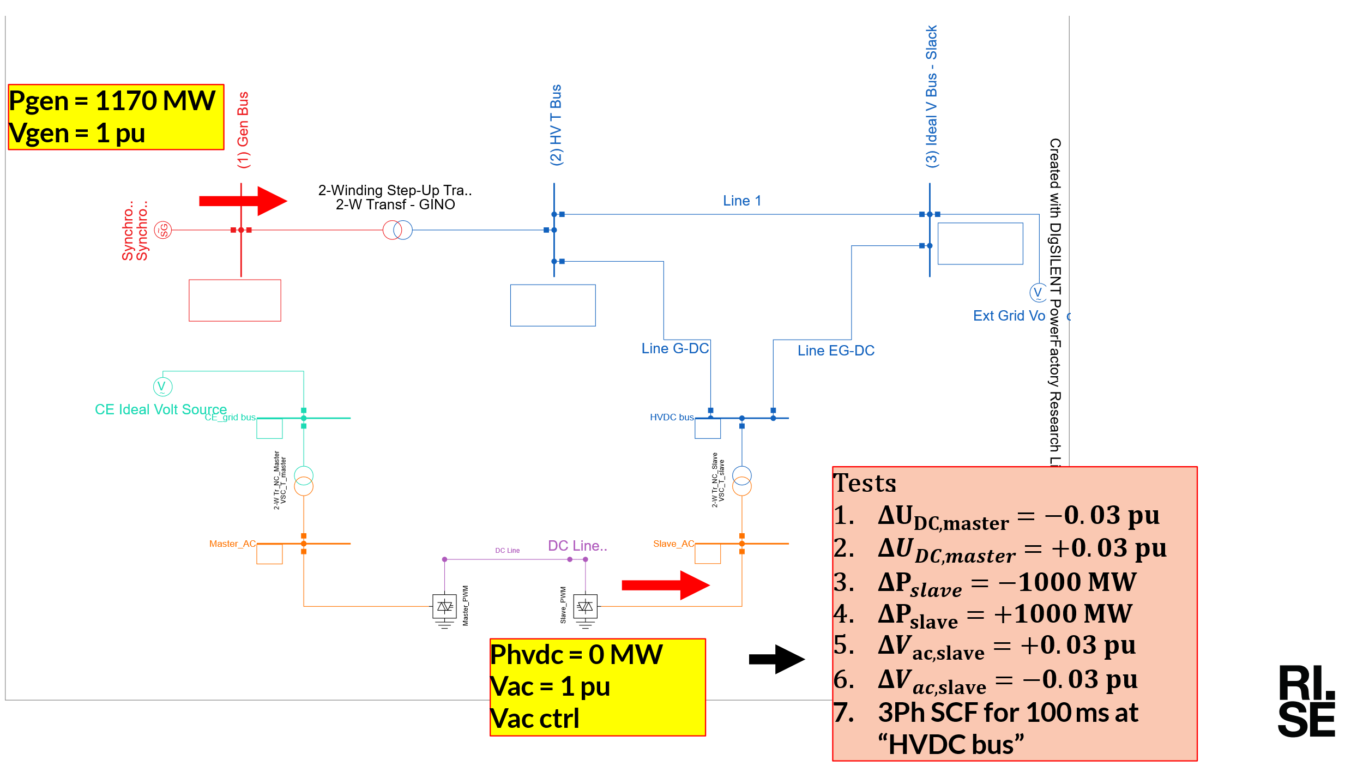

# Zero HVDC power: UDC step down

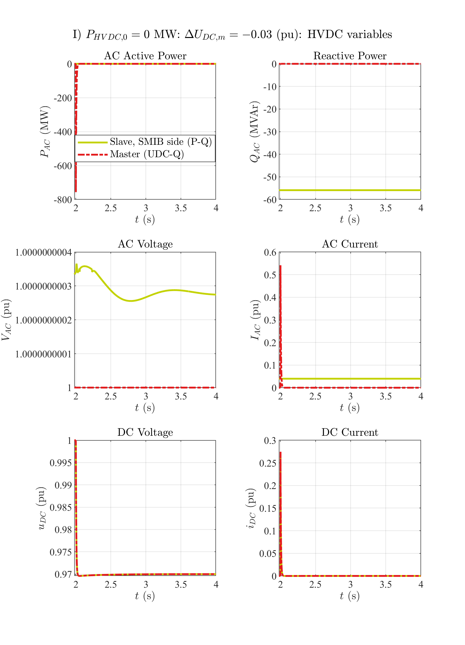

# Zero HVDC power: UDC step down

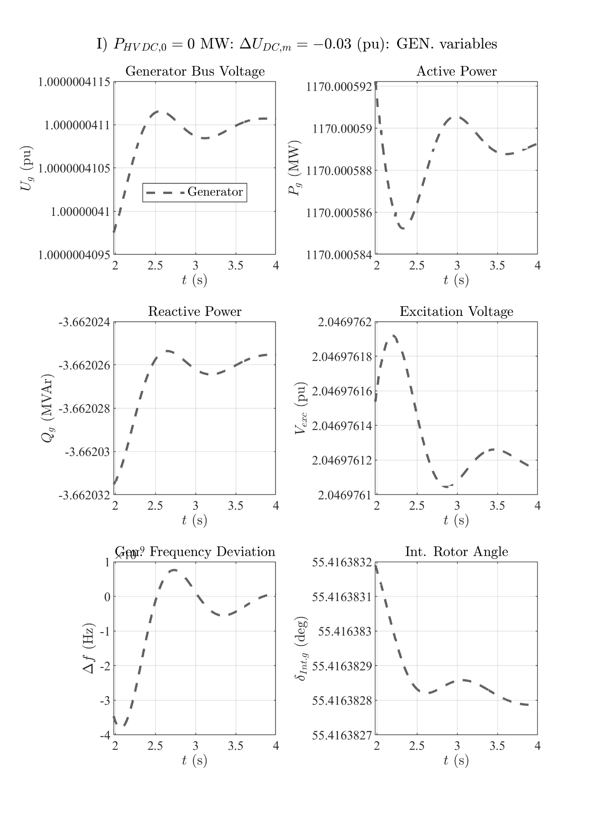

# Zero HVDC power: UDC step up

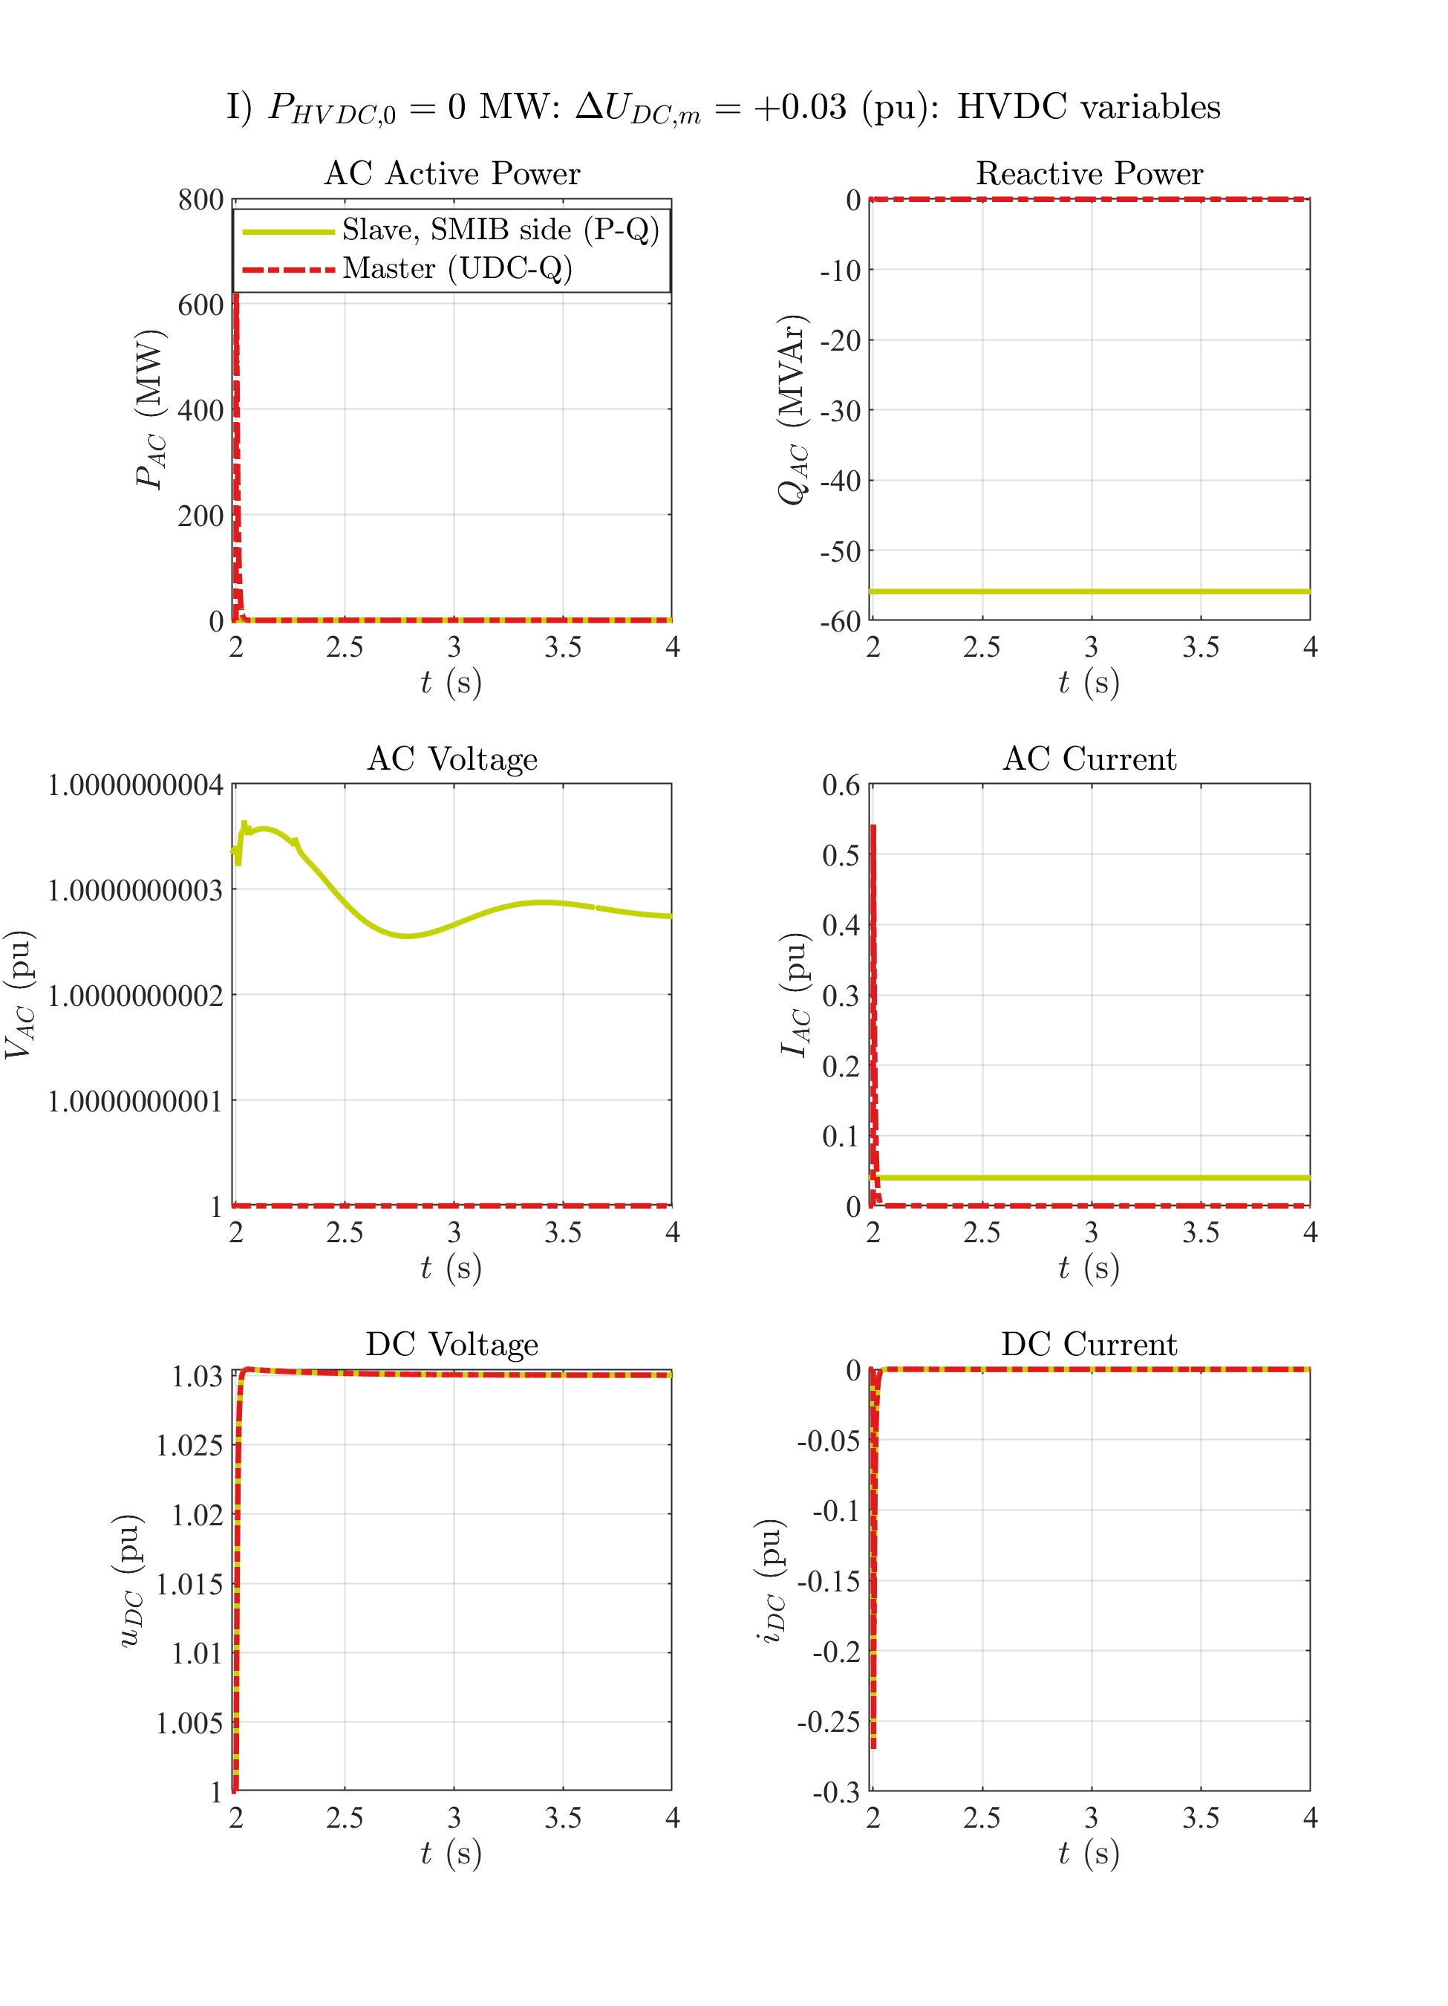

# Zero HVDC power: UDC step up

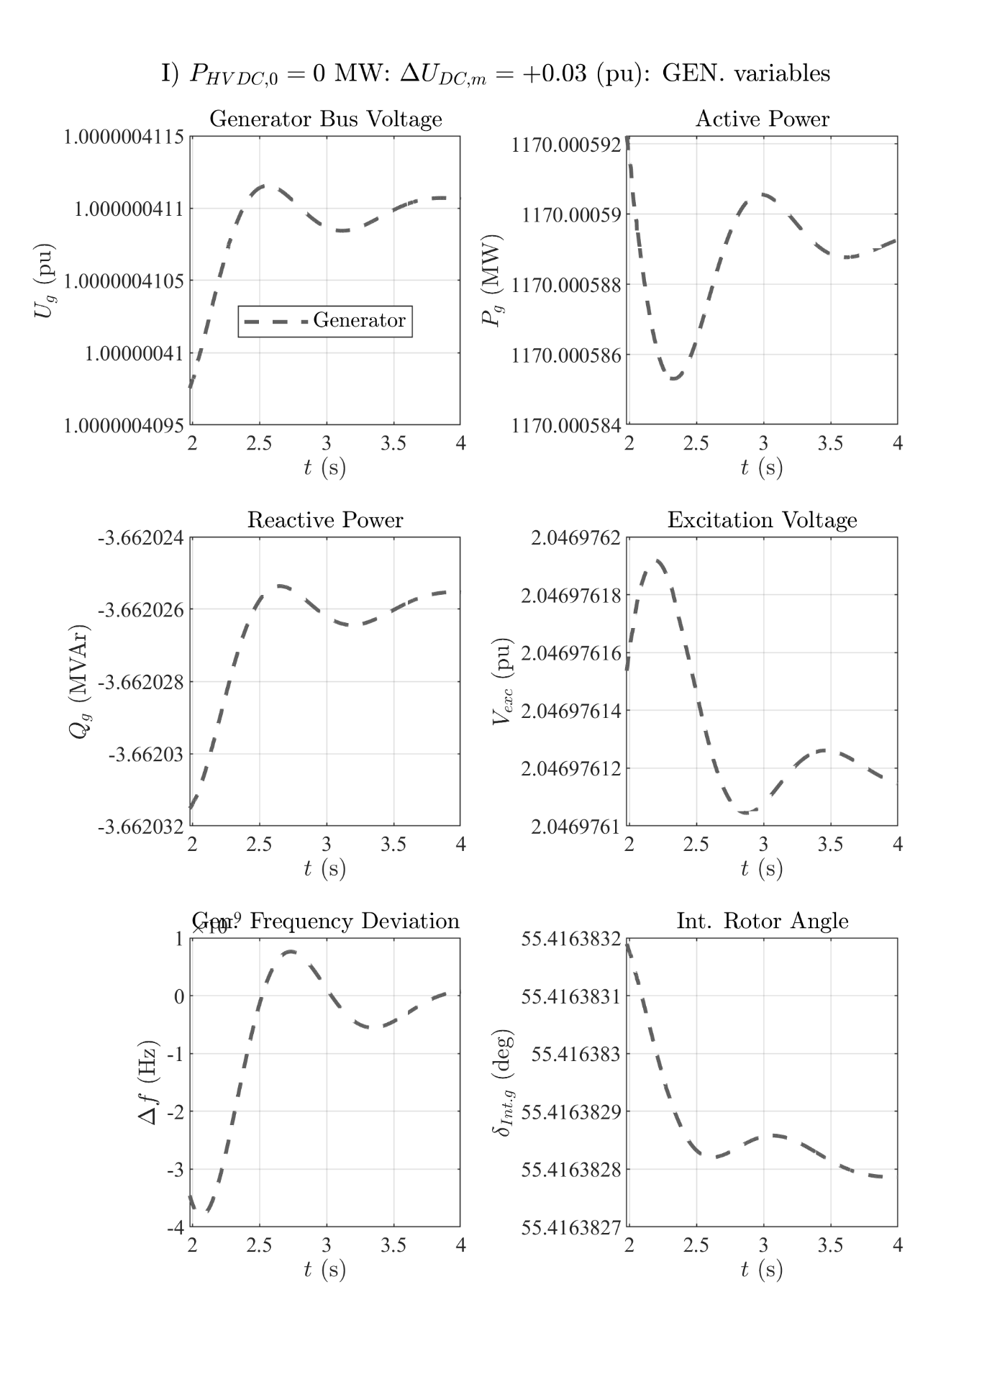

# Zero HVDC power: P step down

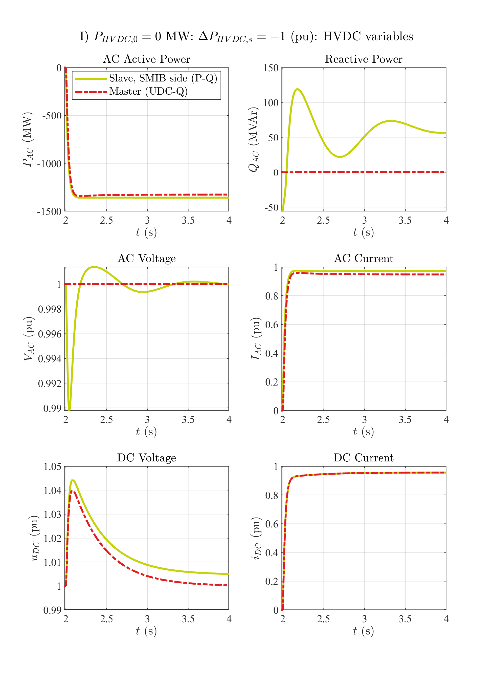

# Zero HVDC power: P step down

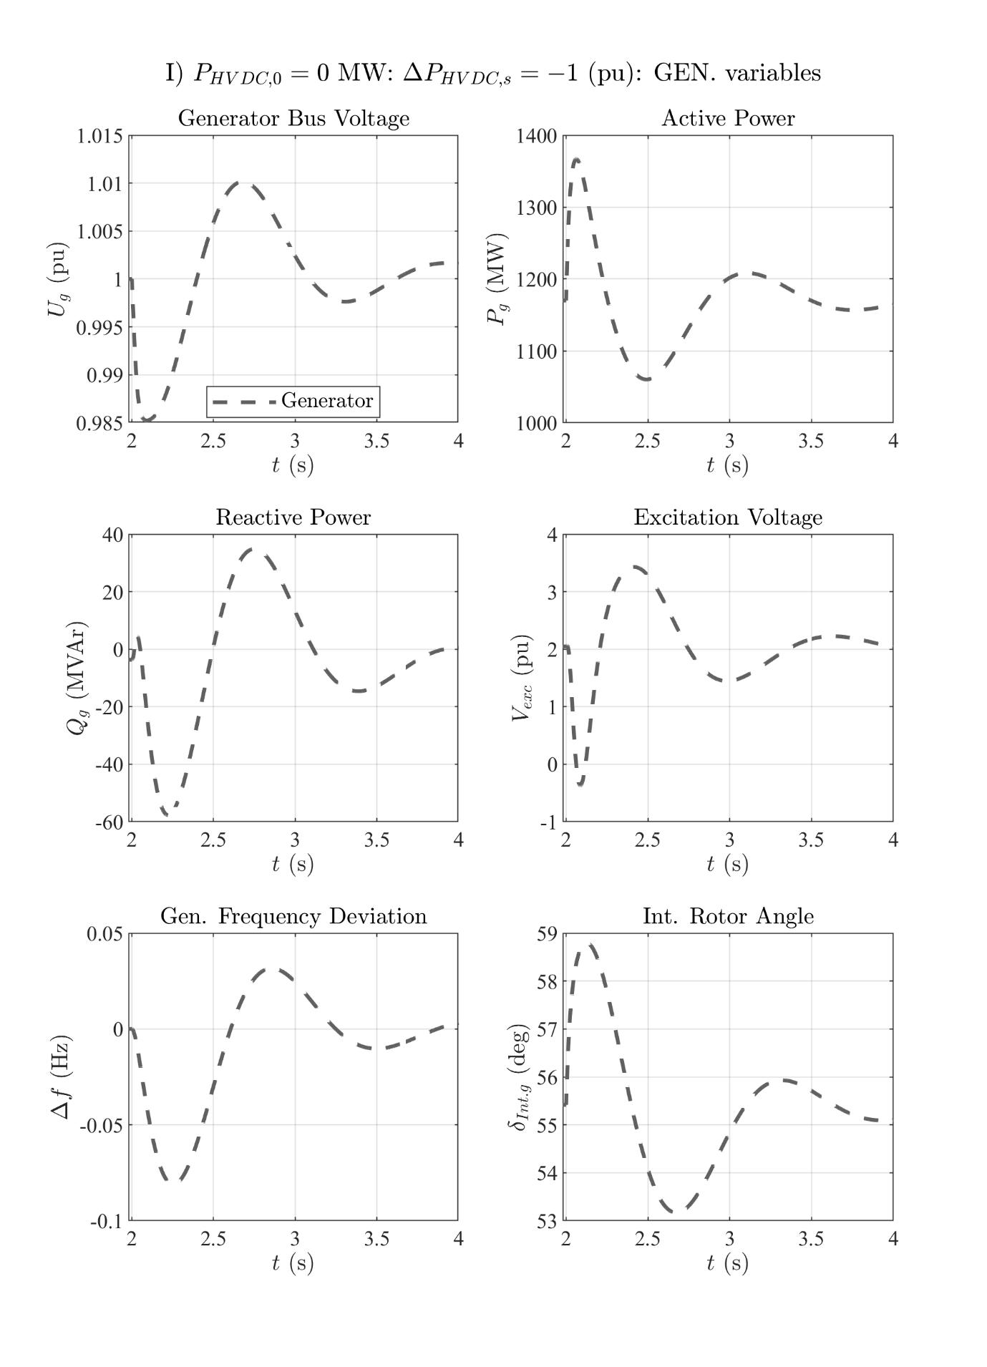

# Zero HVDC power: P step up

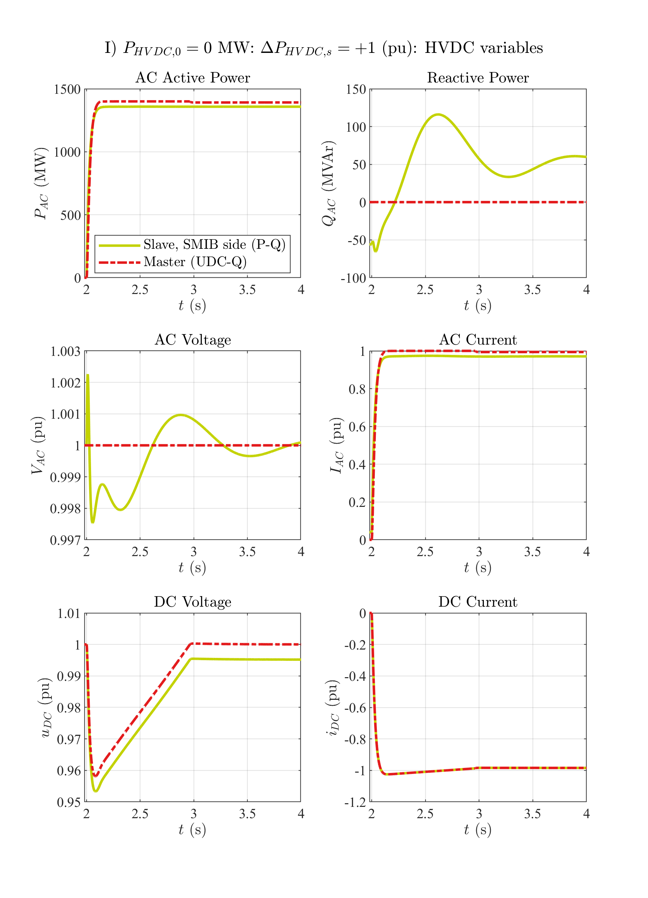

# Zero HVDC power: P step up

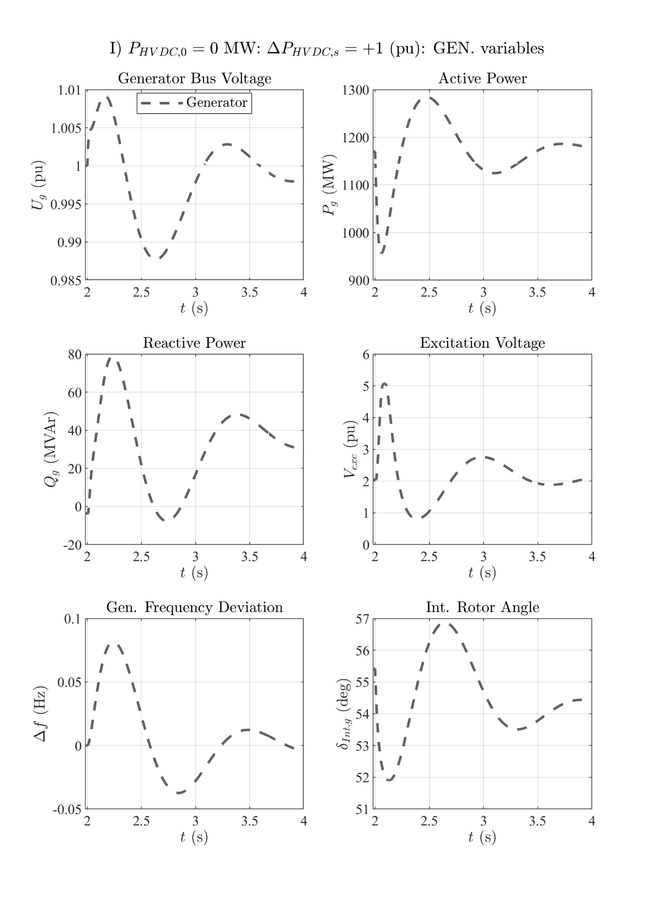

# Zero HVDC power: VAC step up

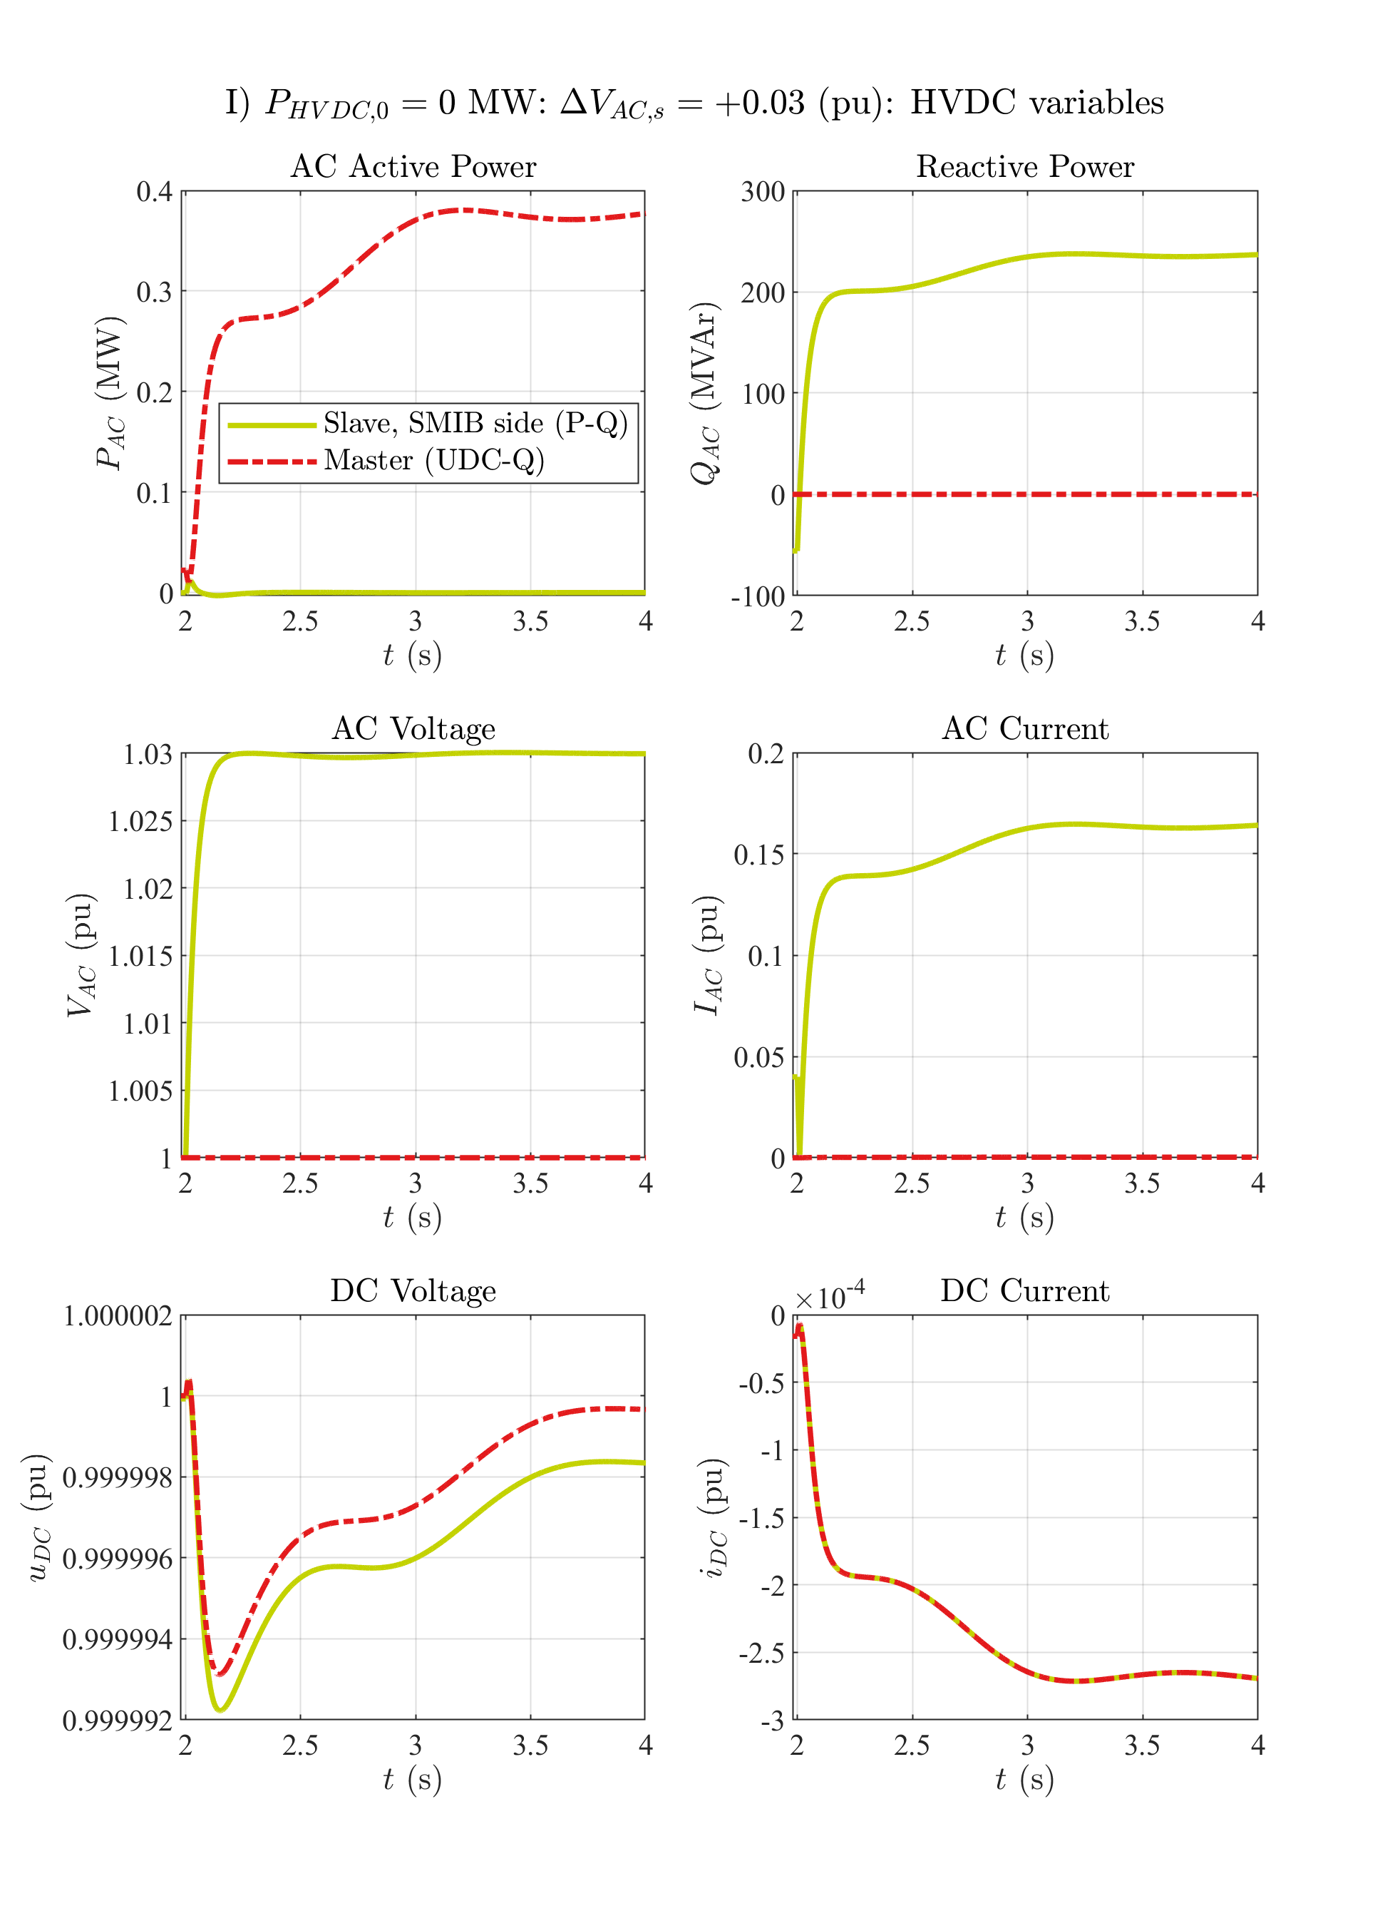

# Zero HVDC power: VAC step up

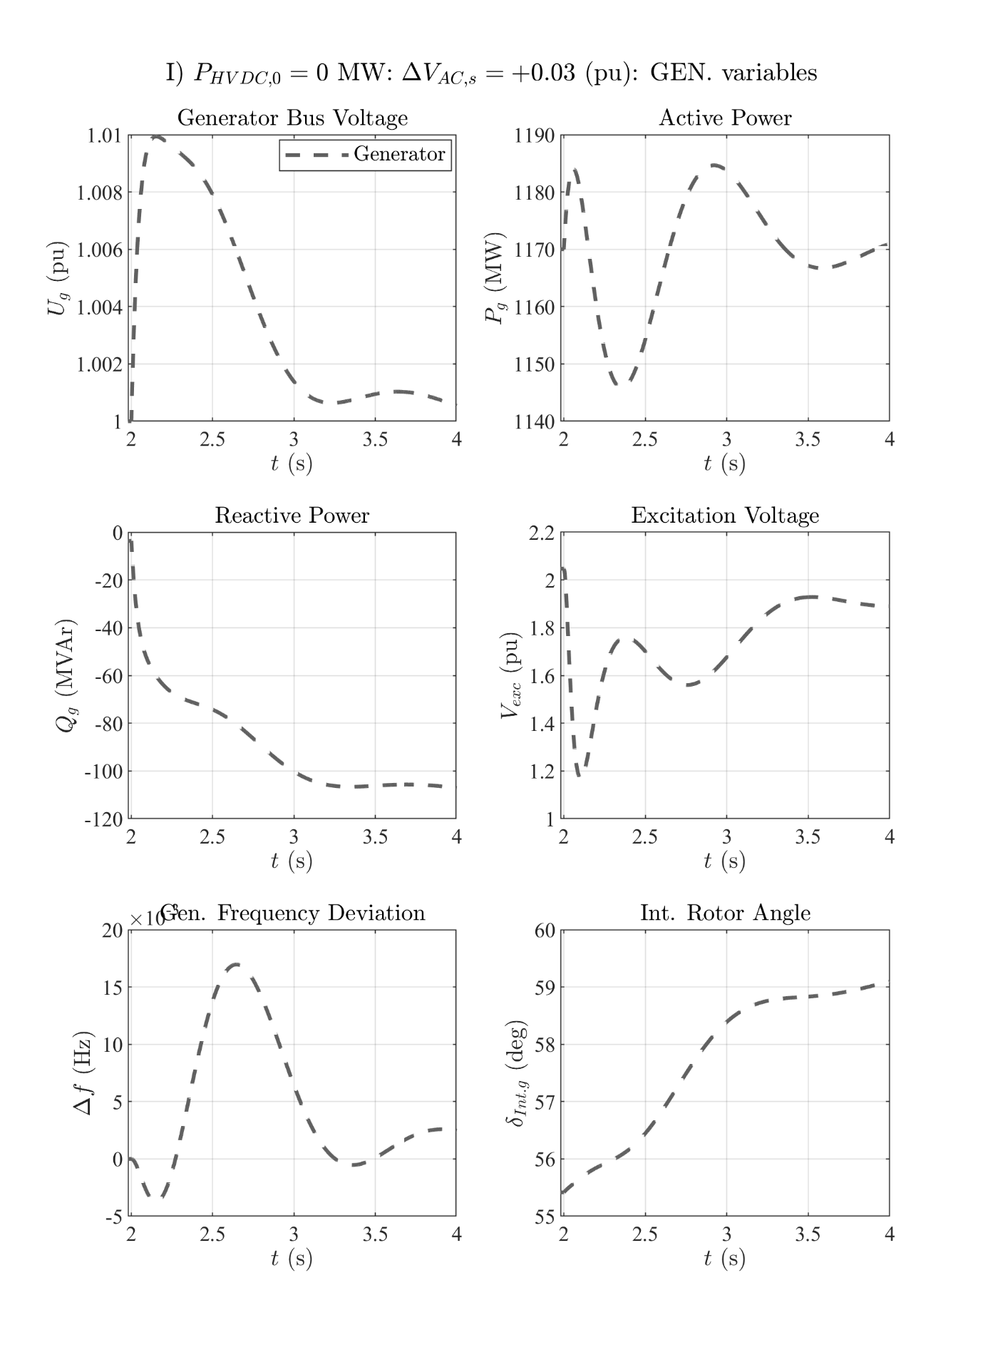

# Zero HVDC power: VAC step down

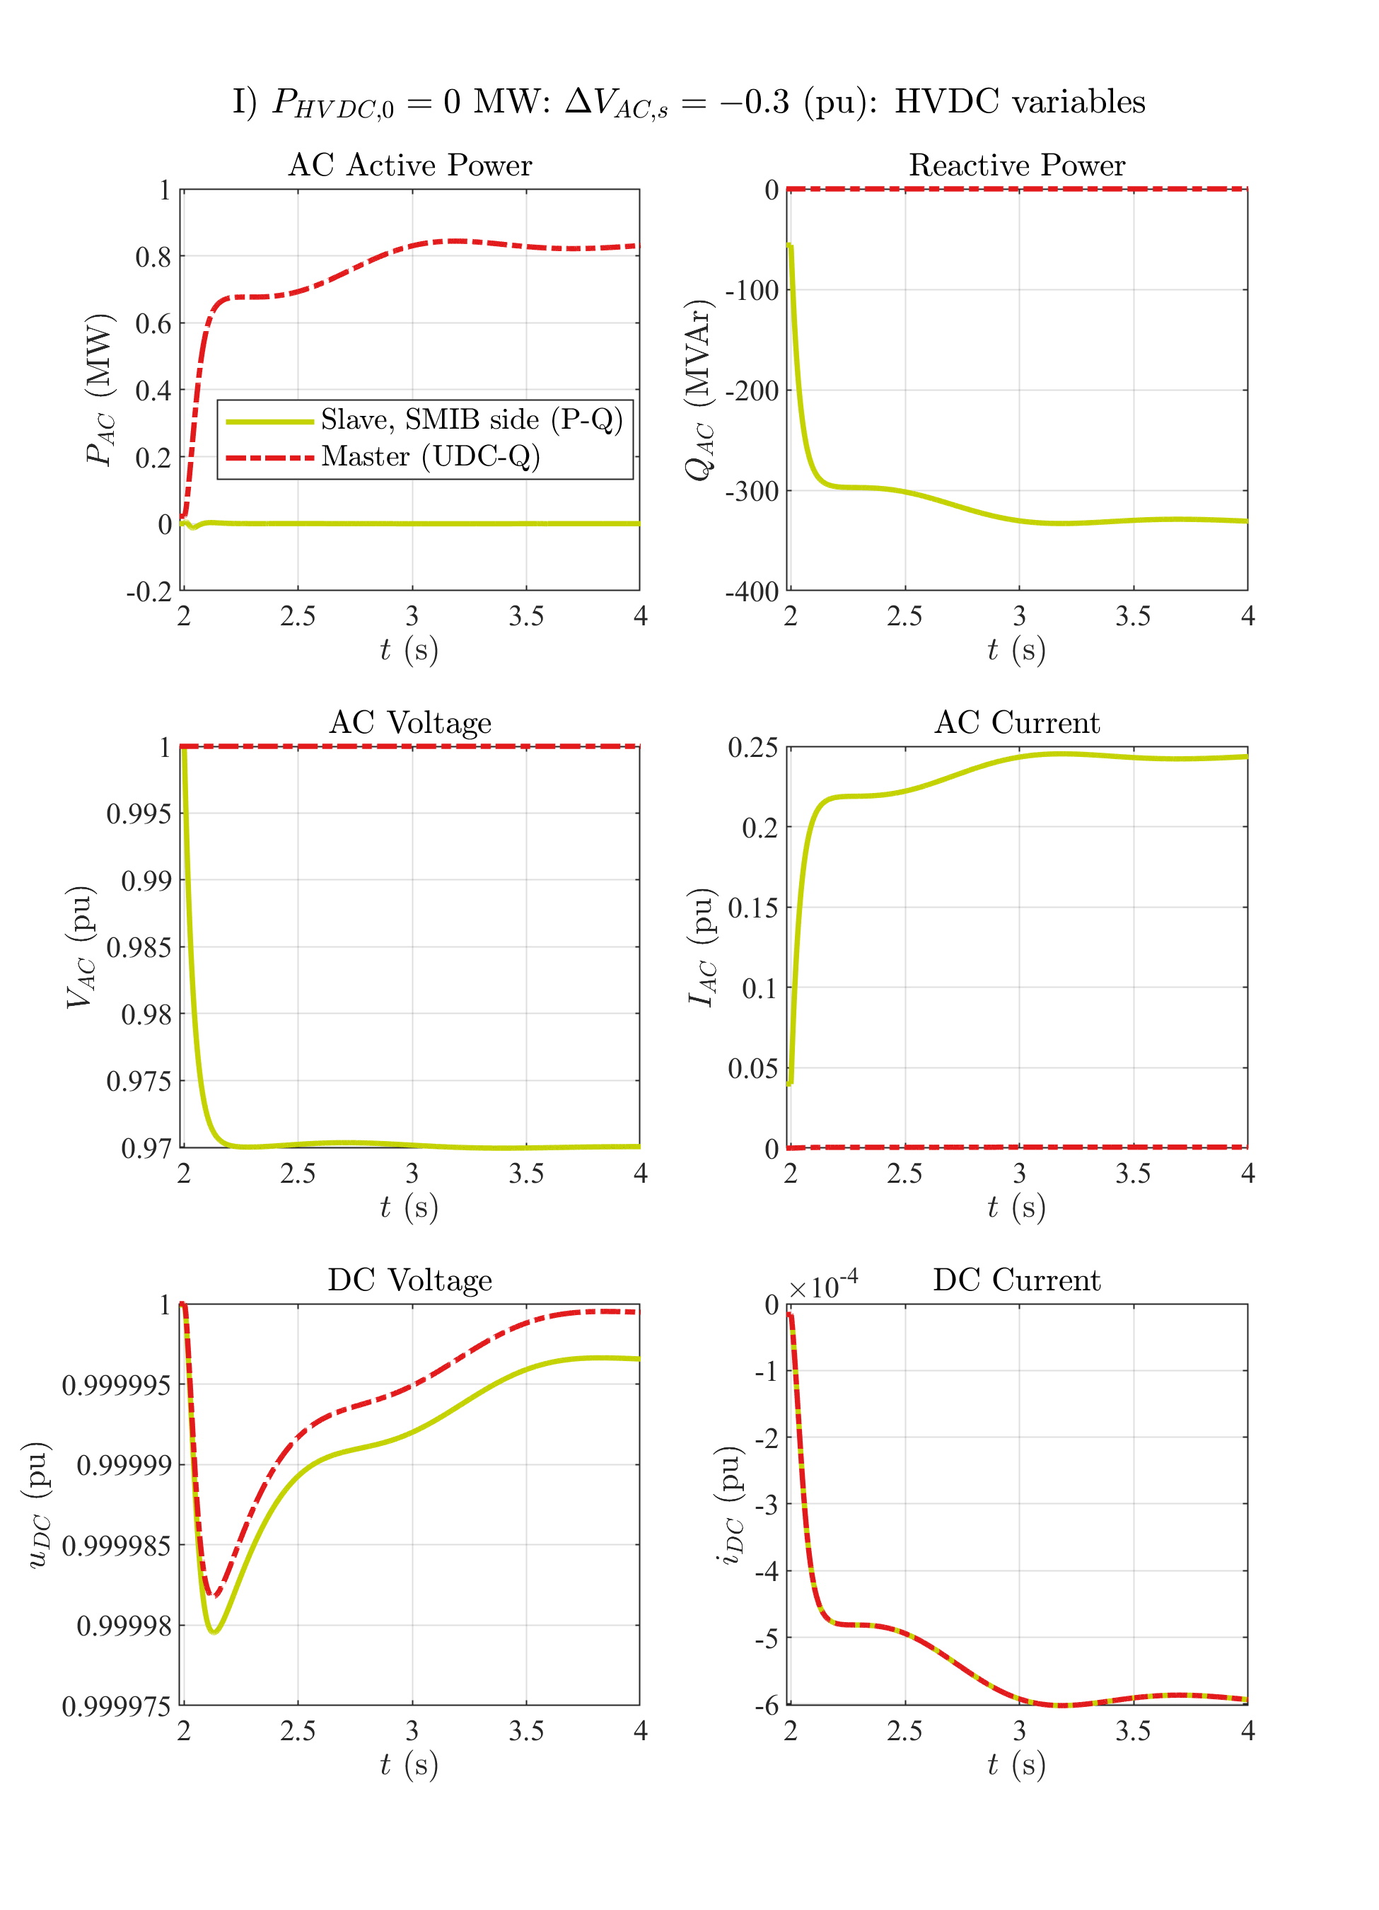

# Zero HVDC power: VAC step down

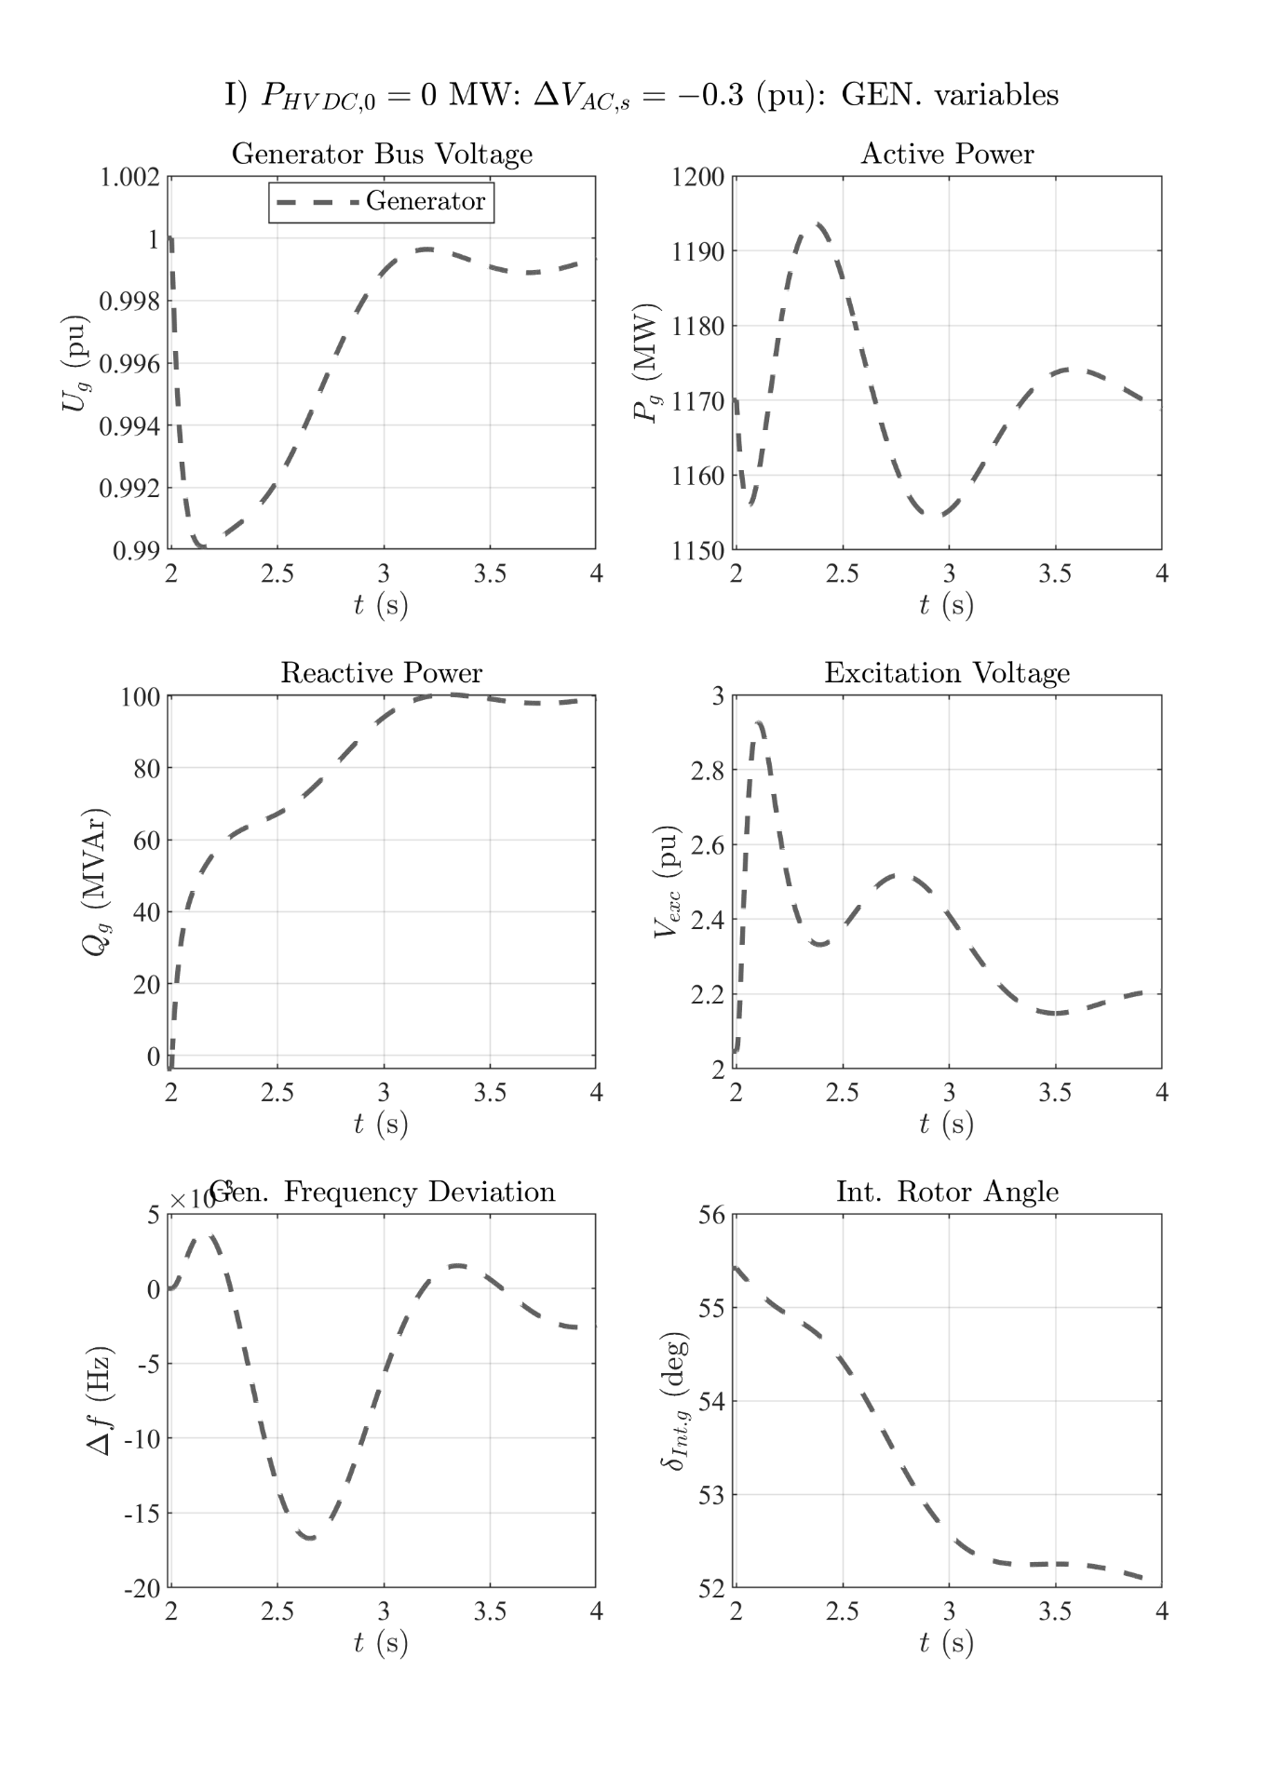

# Zero HVDC power: 3pSC fault at the grid's PCC

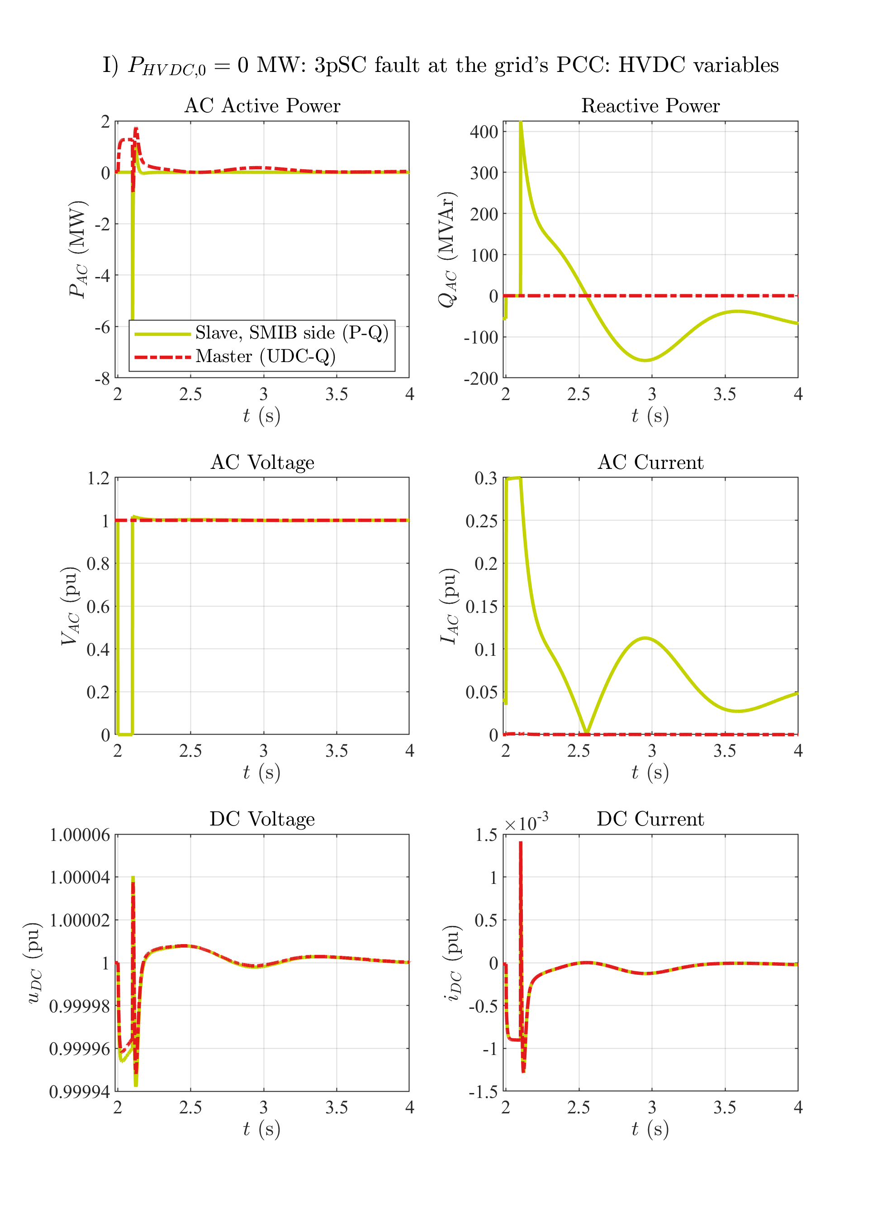

# Zero HVDC power: 3pSC fault at the grid's PCC

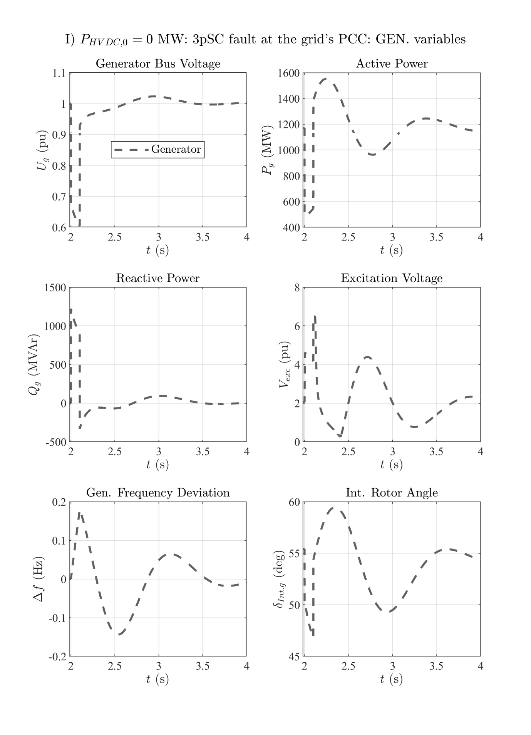

# 1GW HVDC power: Illustration

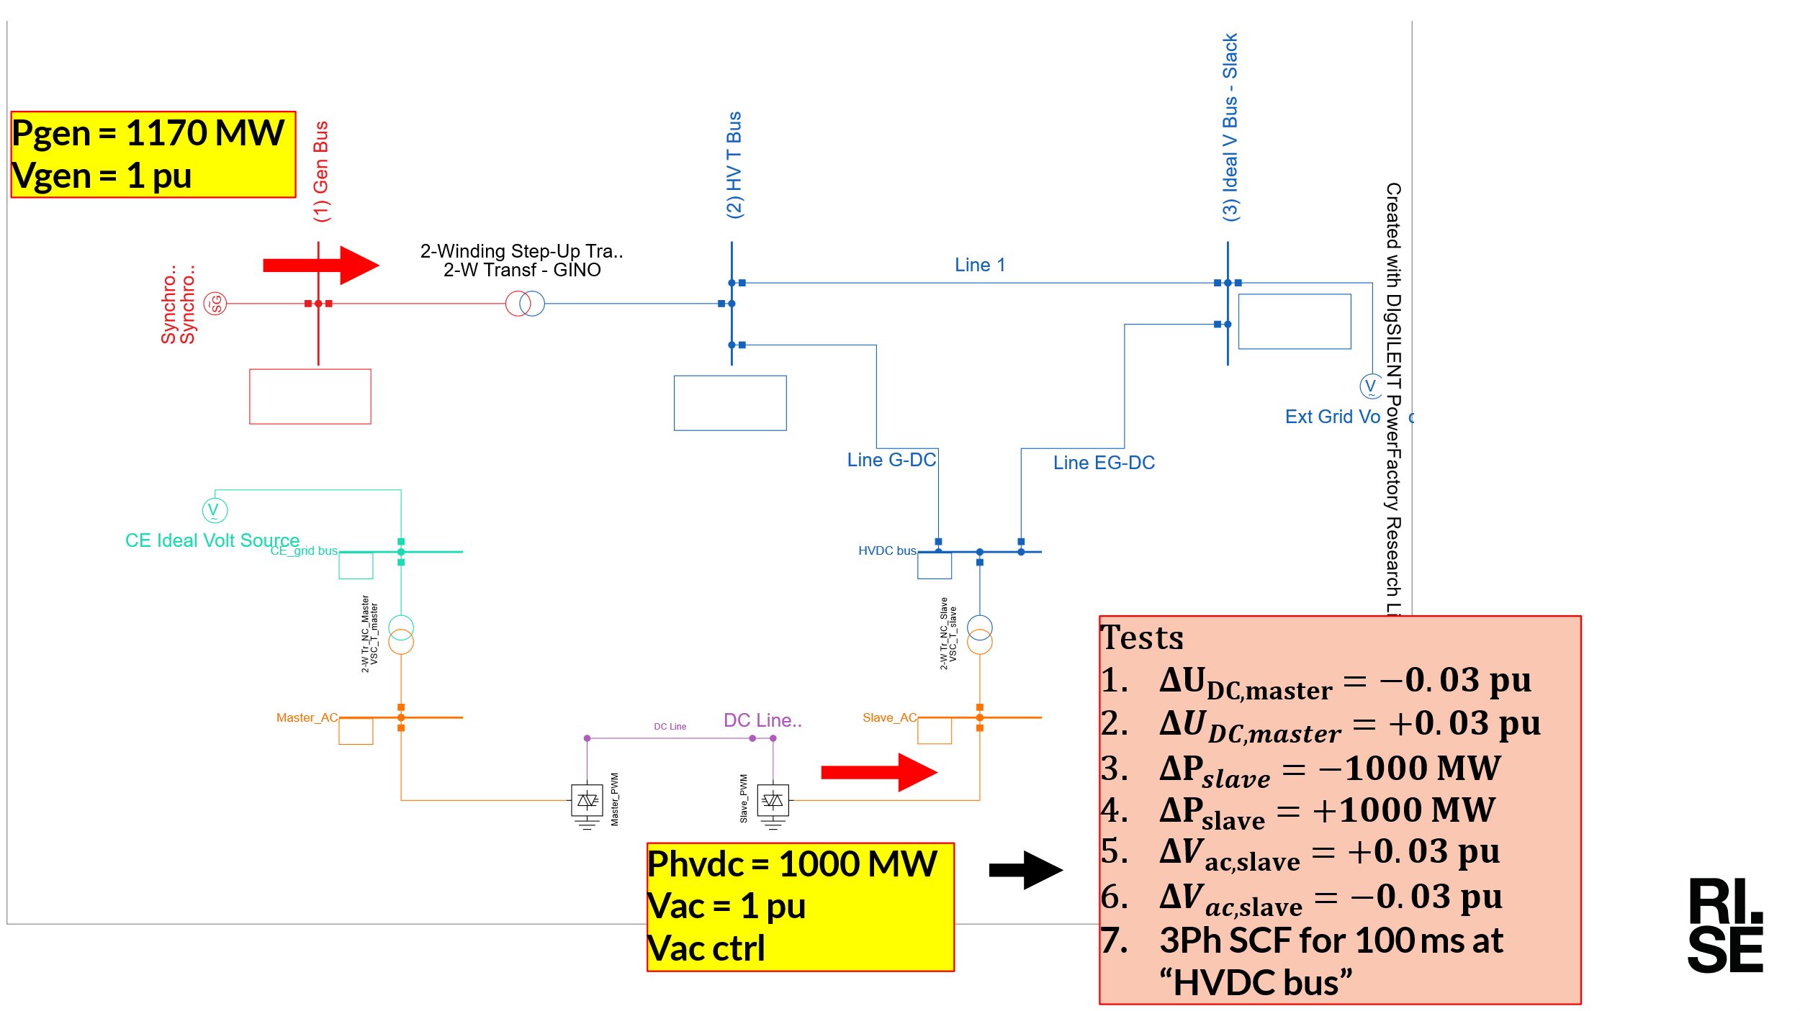

# 1GW HVDC power: UDC step down

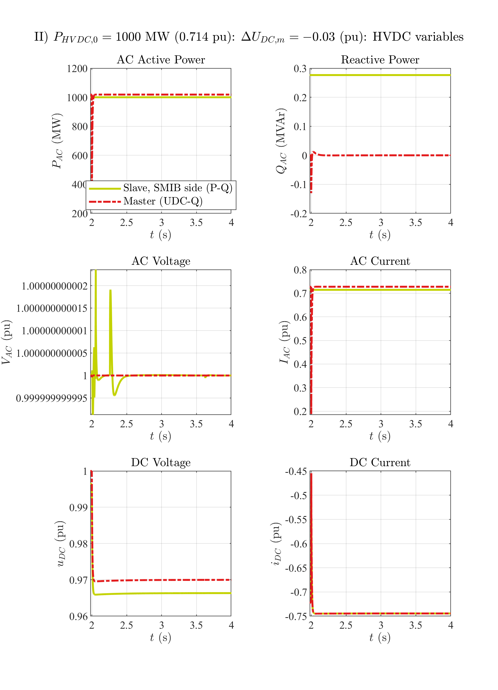

# 1GW HVDC power: UDC step down

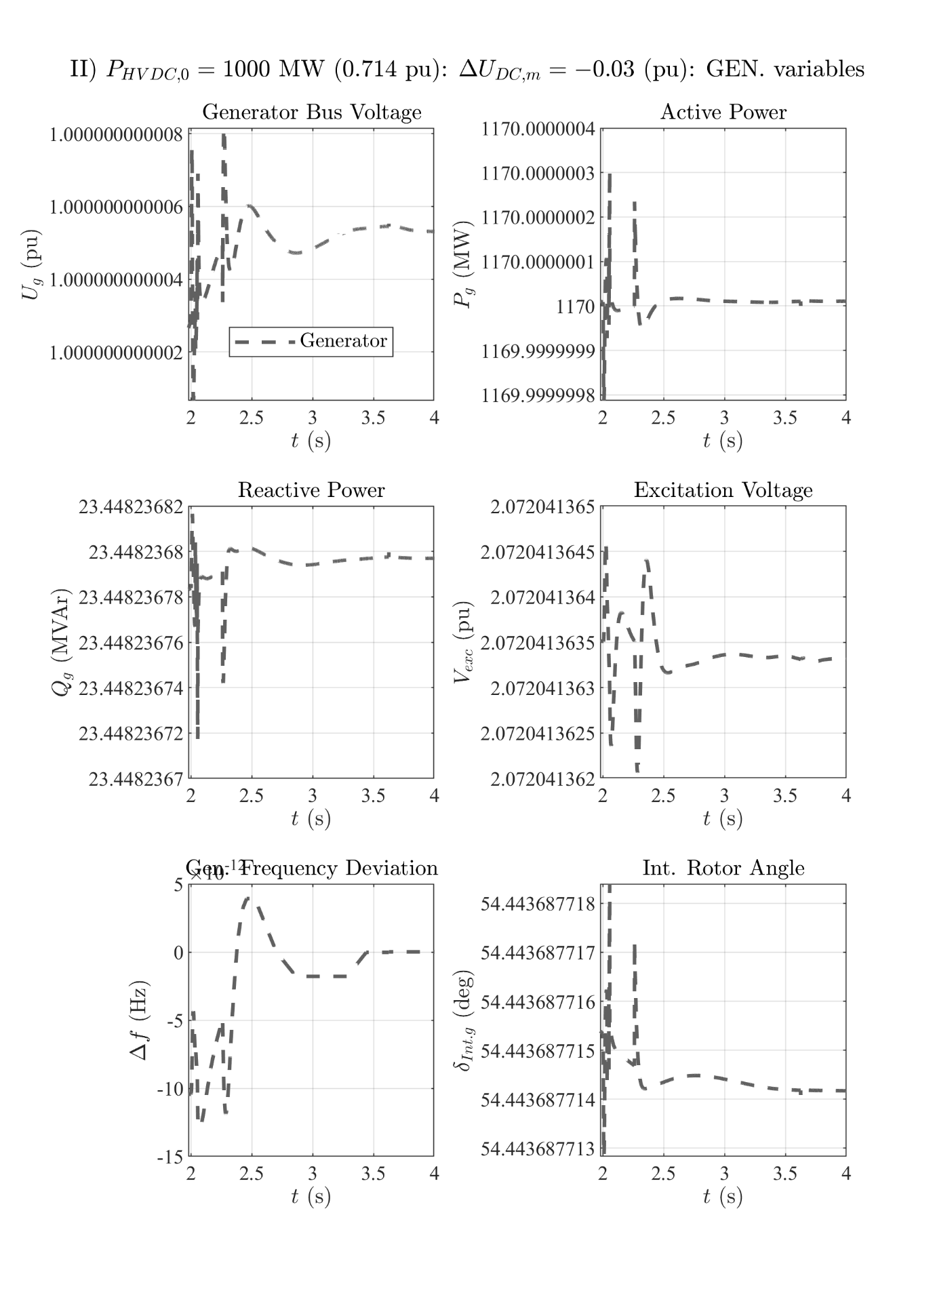

# 1GW HVDC power: UDC step up

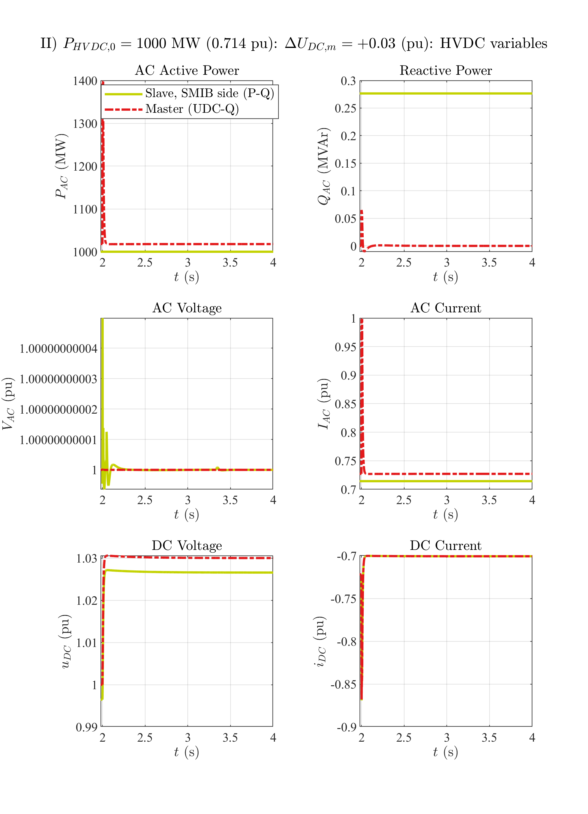

# 1GW HVDC power: UDC step up

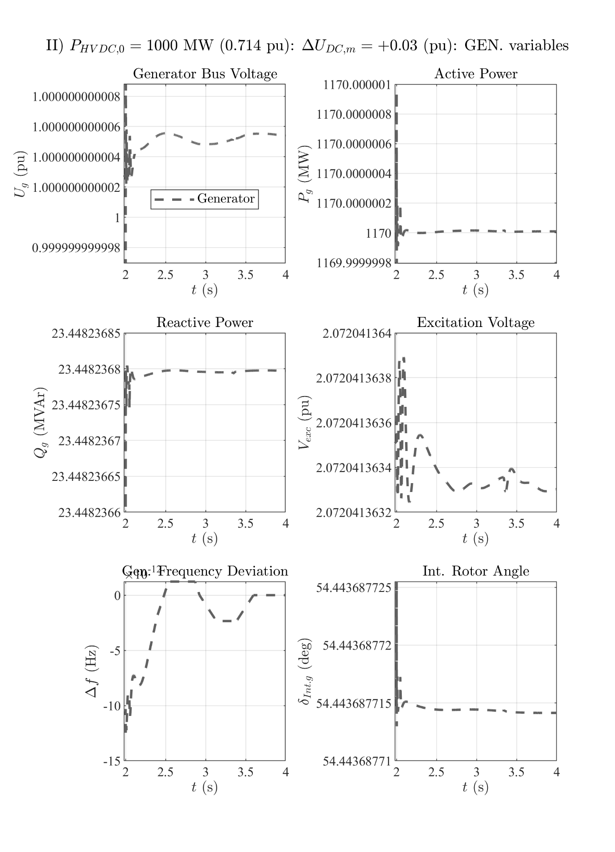

# 1GW HVDC power: P step down

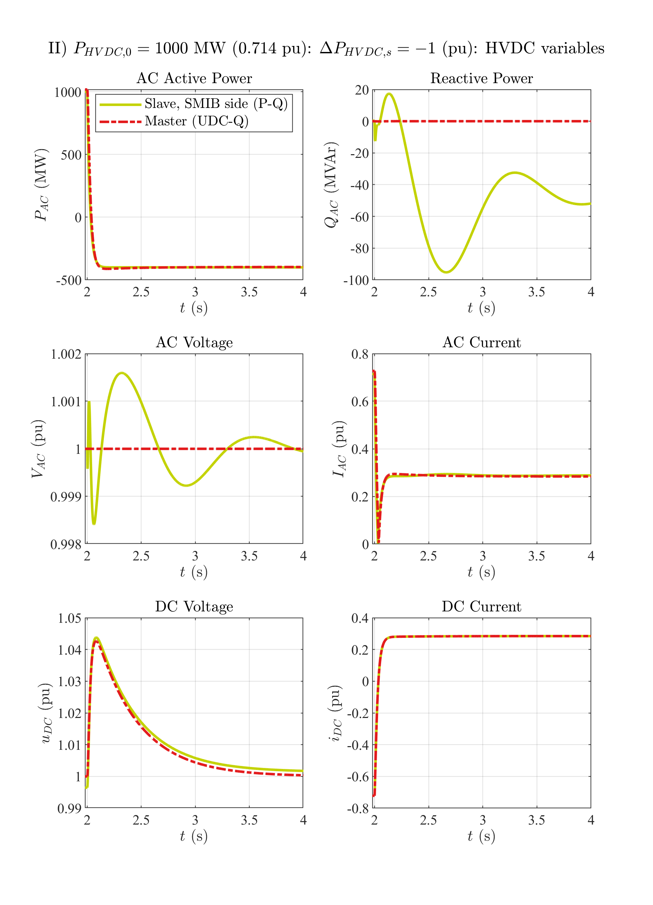

# 1GW HVDC power: P step down

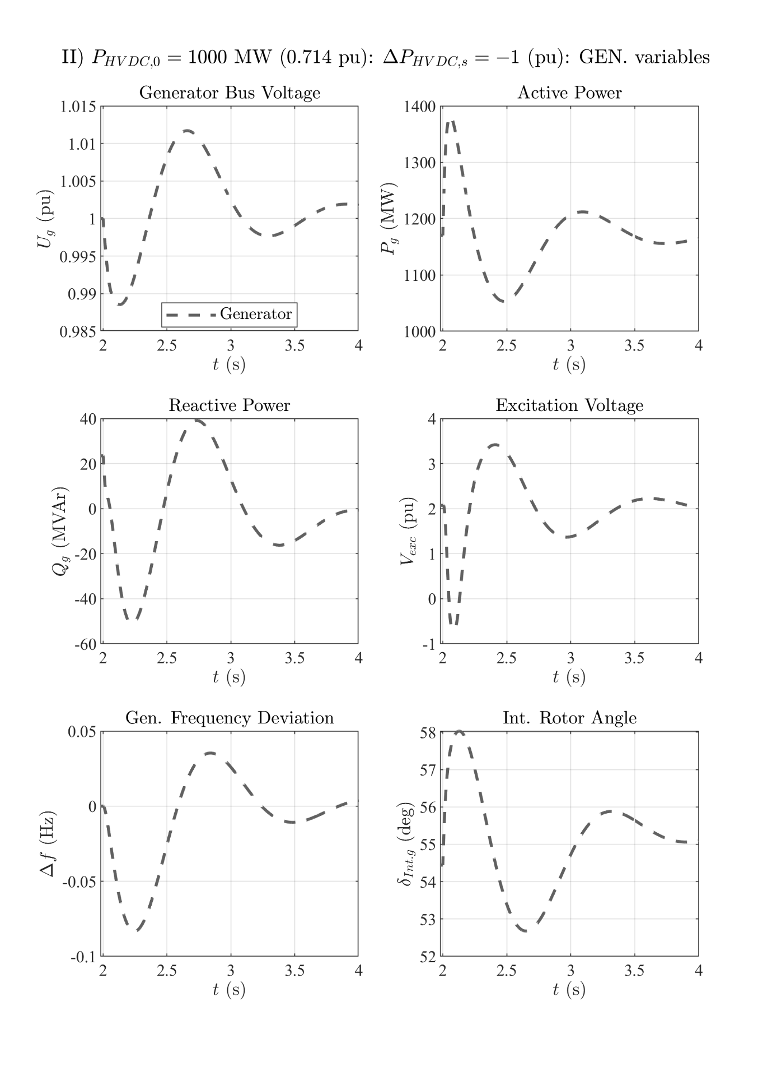

# 1GW HVDC power: P step up

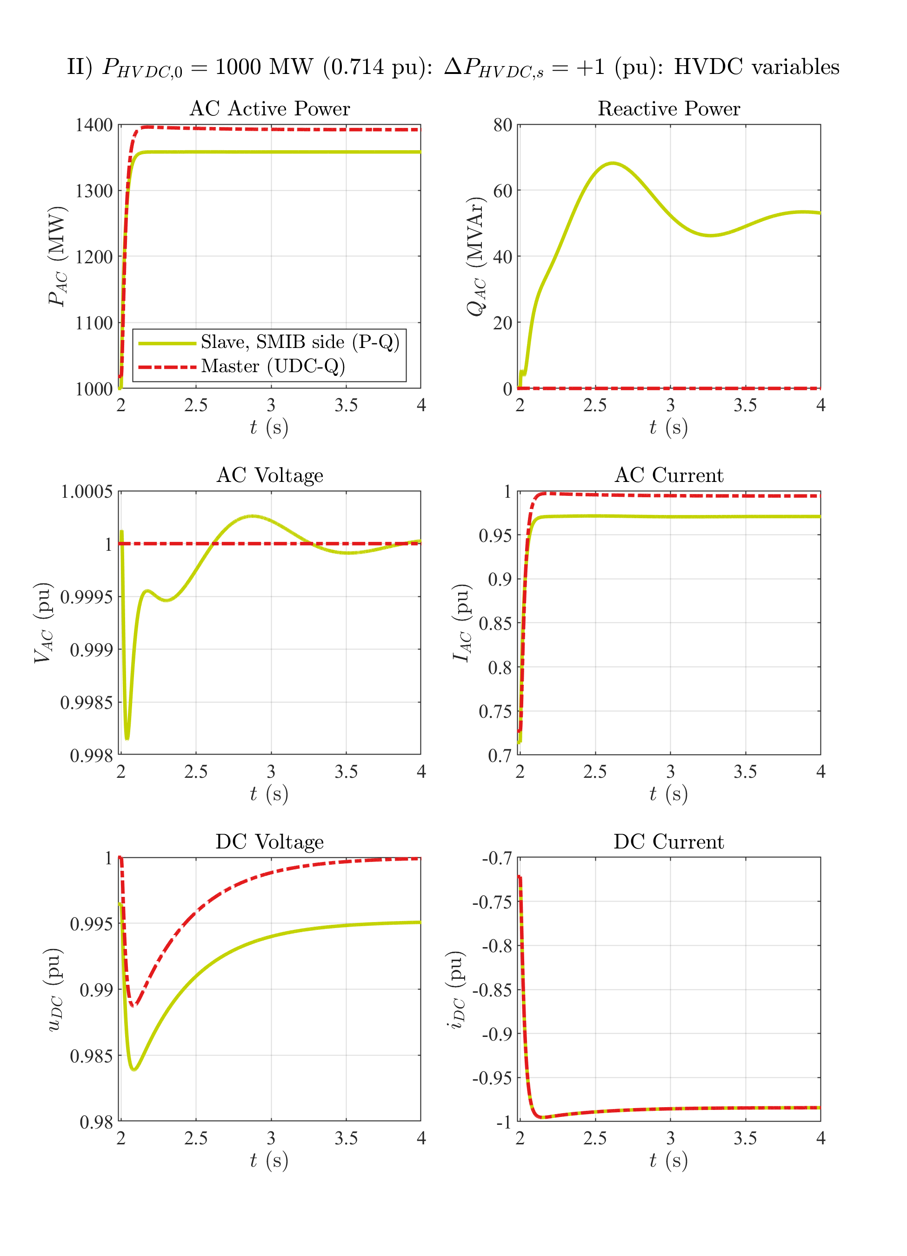

# 1GW HVDC power: P step up

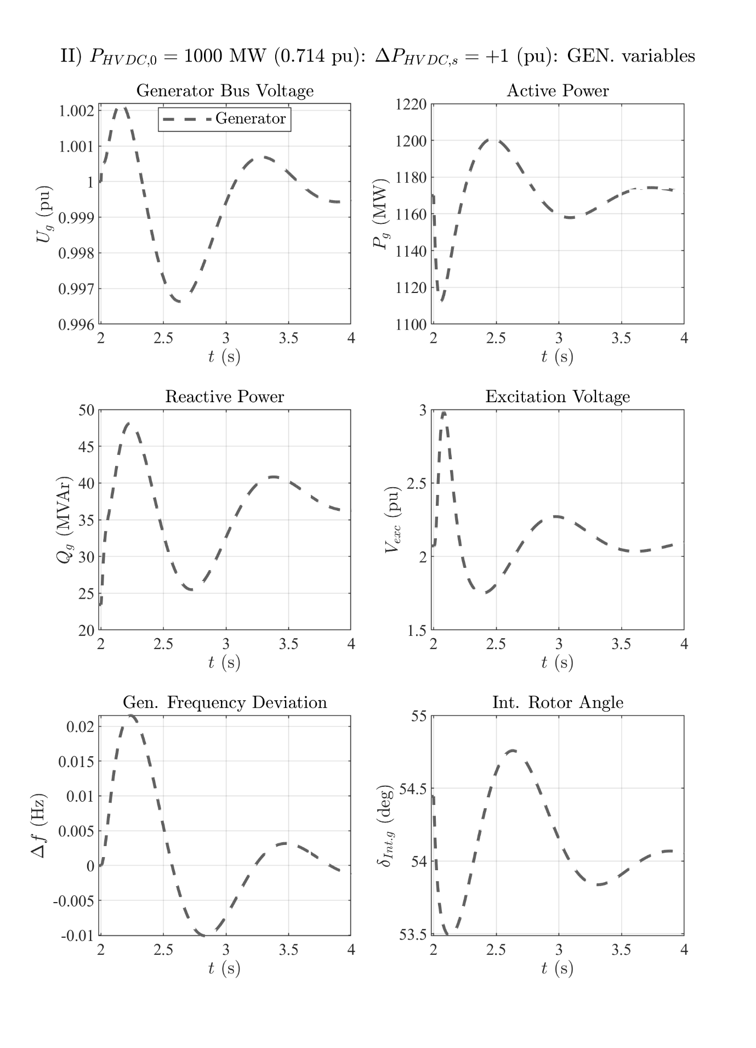

# 1GW HVDC power: VAC step up

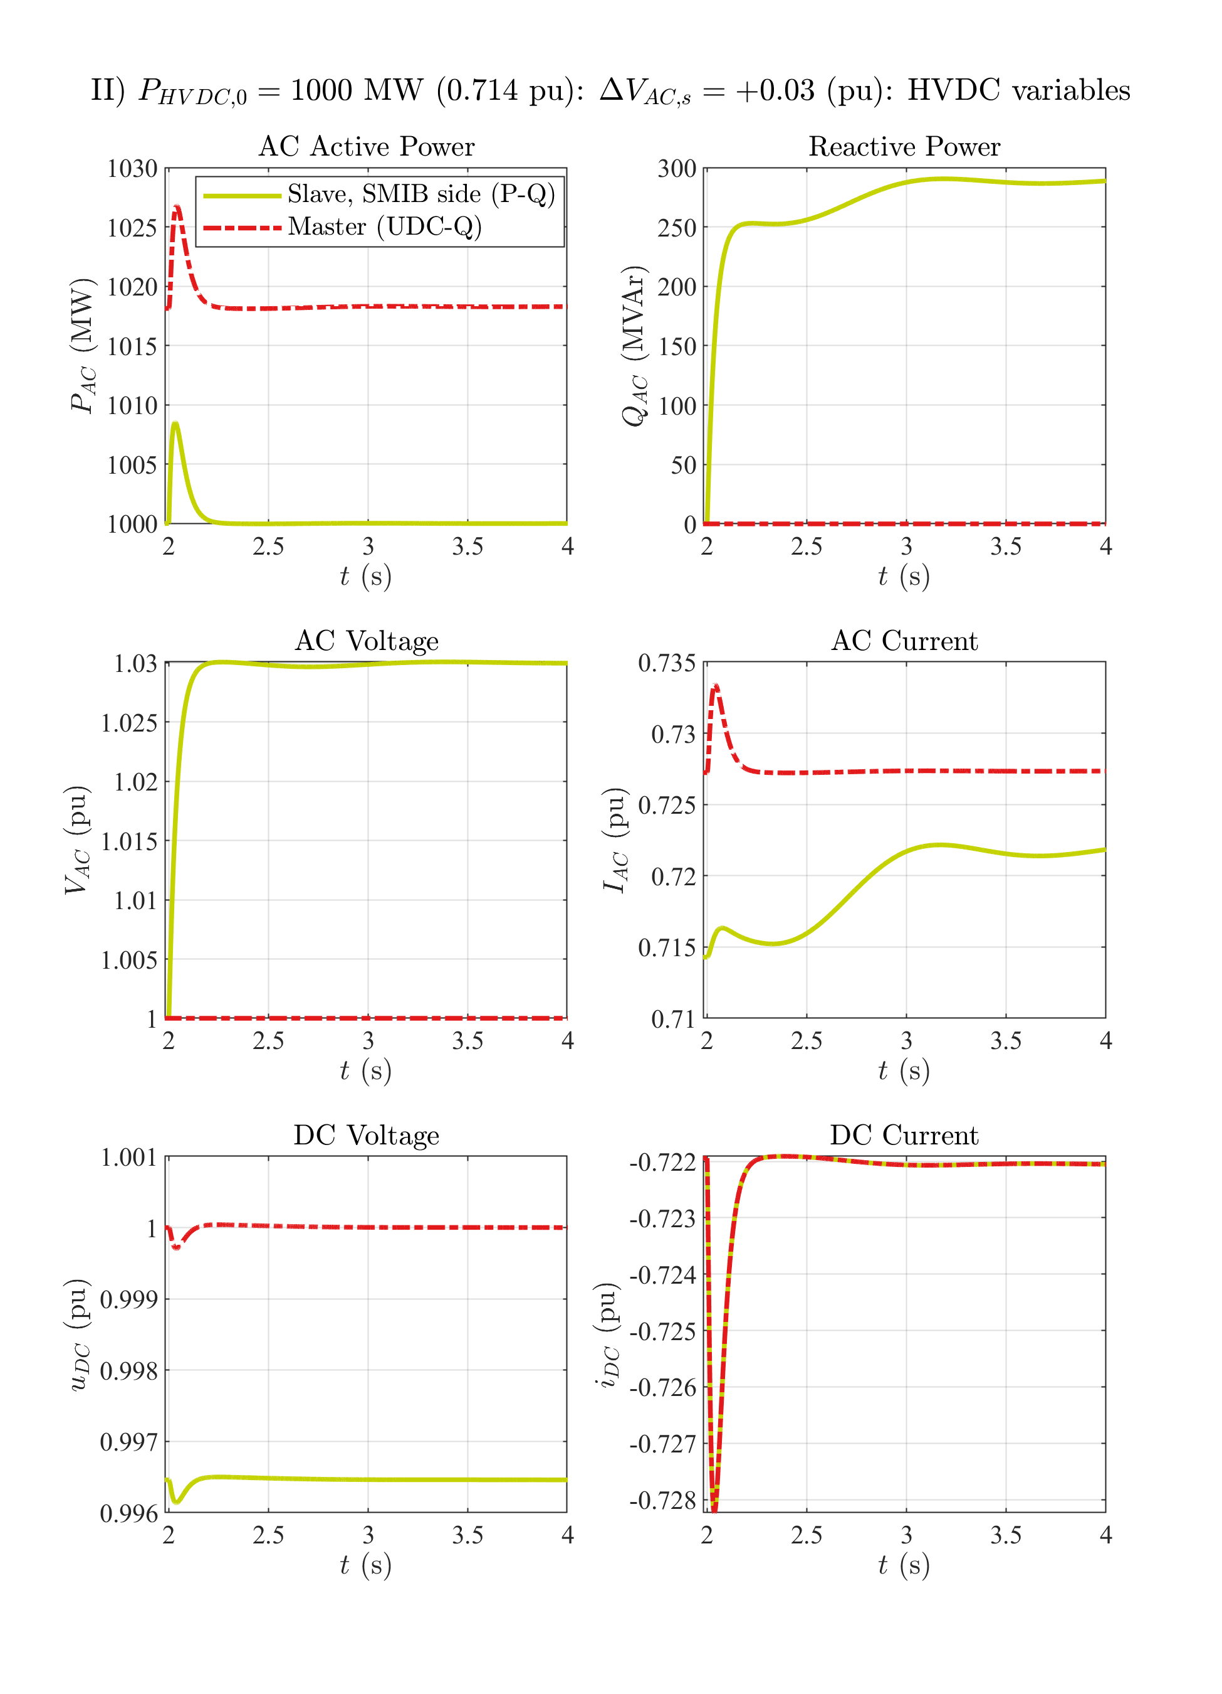

# 1GW HVDC power: VAC step up

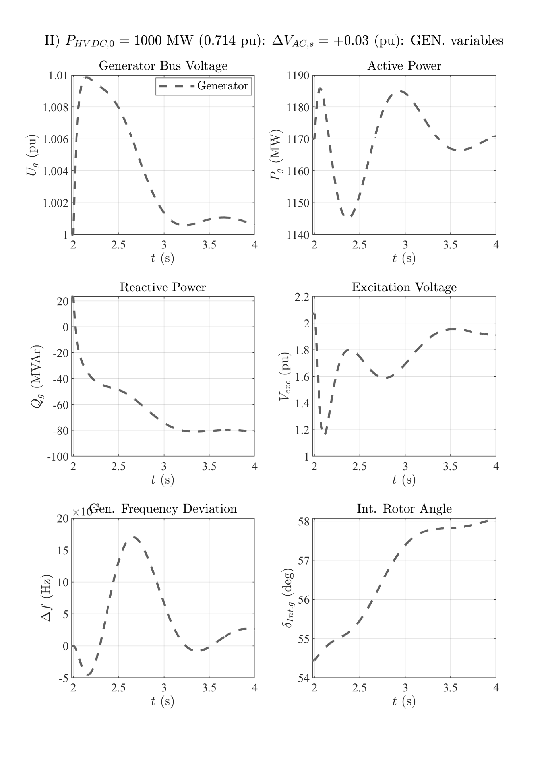

# 1GW HVDC power: VAC step down

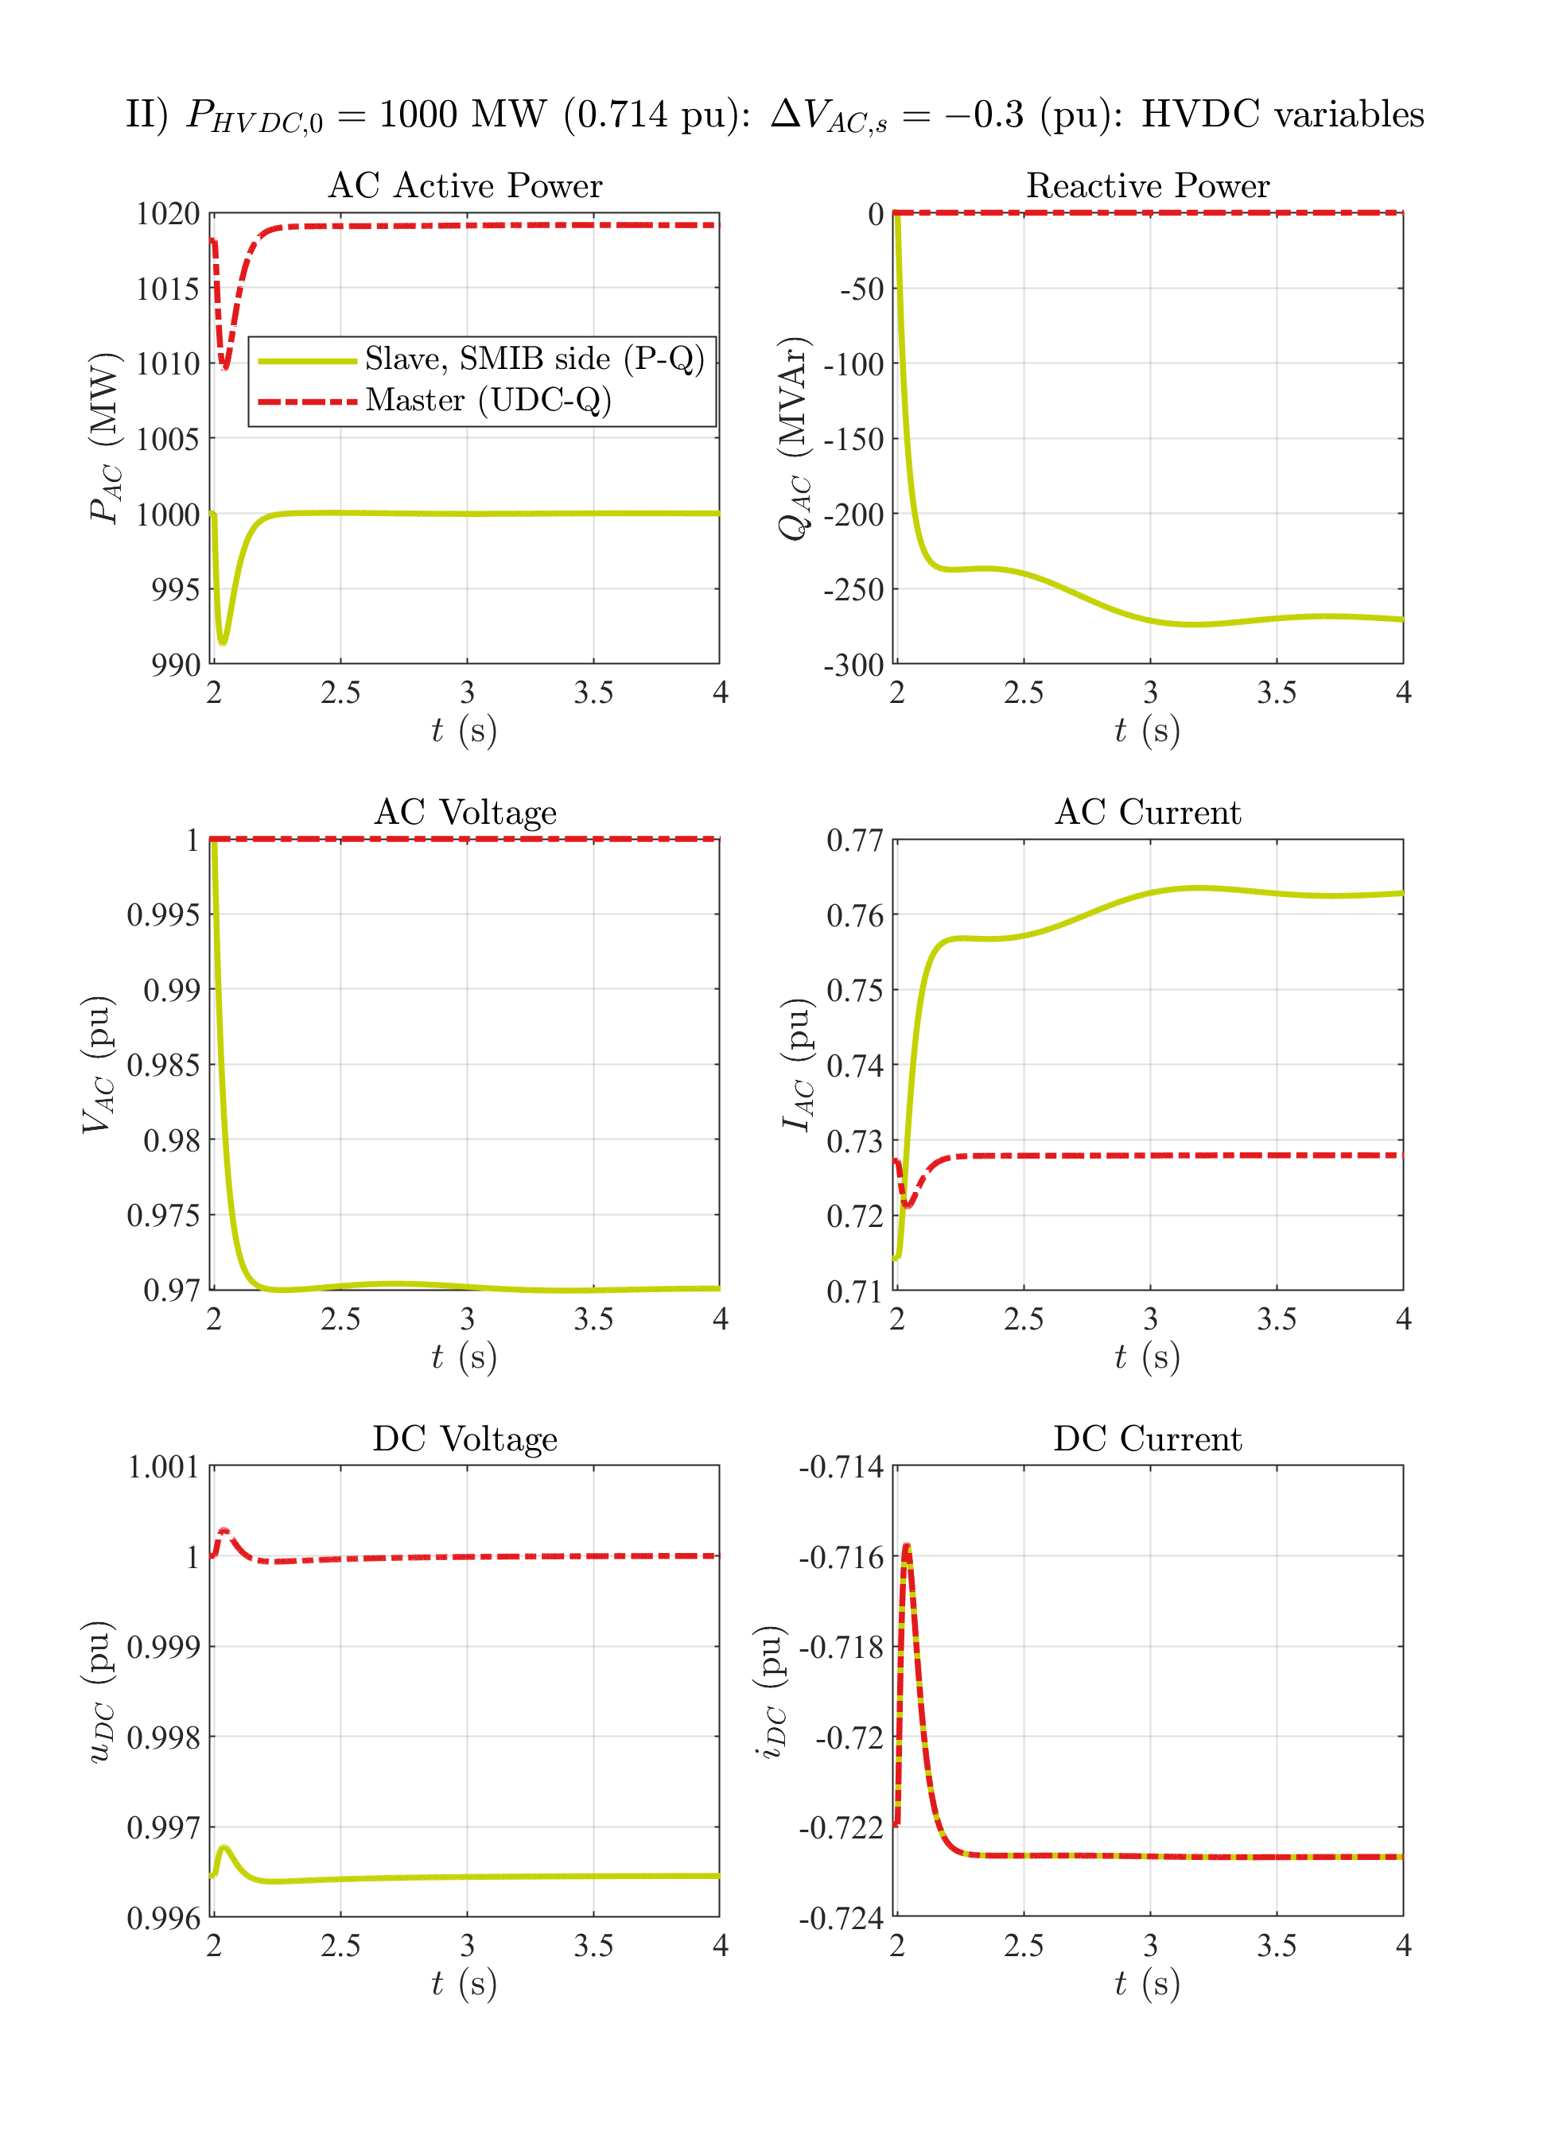

# 1GW HVDC power: VAC step down

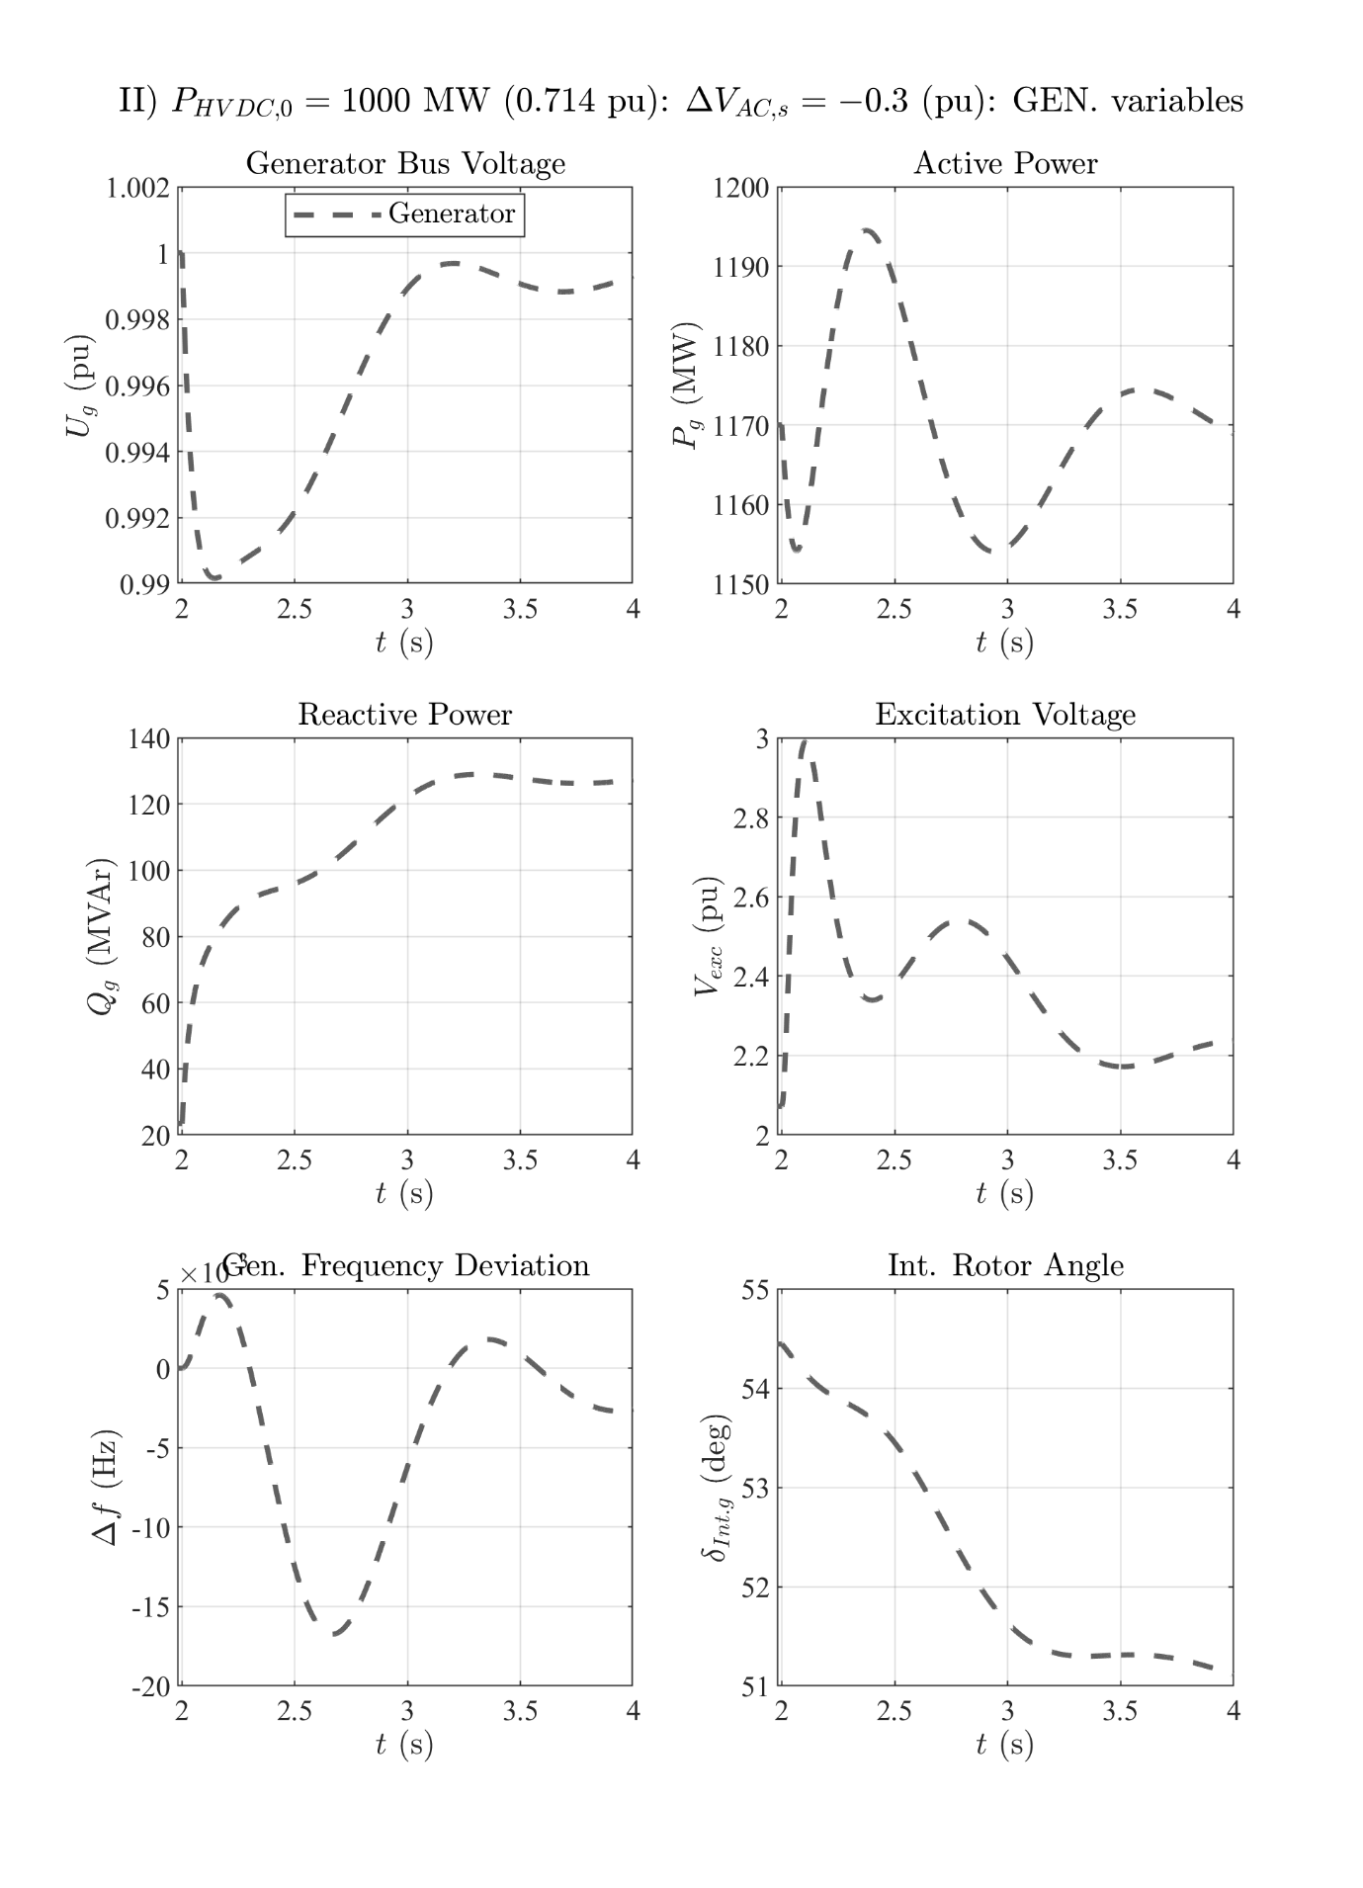

# 1GW HVDC power: 3pSC fault at the grid's PCC

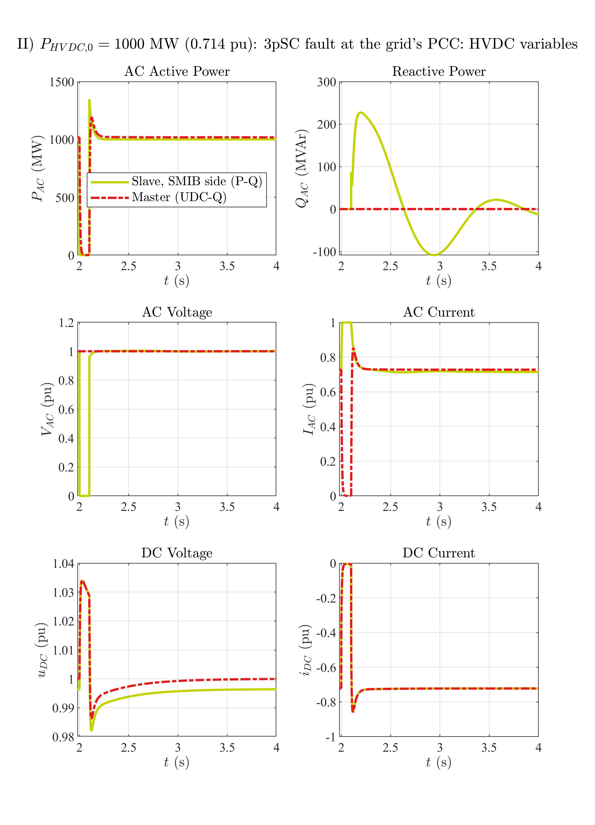

# 1GW HVDC power: 3pSC fault at the grid's PCC

